AWS Feedback Management System

Work Integrated Project

Karthikeyan Jeyabalasuntharam

Program: Cloud Computing Technologies (T465)

Group Name: CloudZen

Contents

Project Overview 3

Objectives 3

AWS Architecture Diagram 4

AWS Resource 6

Implementation Steps 7

Conclusion 37

# Project Overview

The AWS Feedback Management System is a multi-tier cloud application designed to collect, process, analyze, and visualize feedback from users in real-time. It is deployed entirely on Amazon Web Services (AWS) using secure, scalable, and highly available architecture.

The system follows a **three-tier architecture**:

* **Frontend (Presentation Layer)** – Provides a user interface where users submit feedback through a form.
* **Backend (Application Layer)** – Processes incoming feedback, stores it in the database, and integrates with AWS Comprehend for sentiment analysis.
* **Database (Data Layer)** – Stores persistent feedback data, including sentiment analysis.

A key feature of this system is Auto Scaling, which automatically adjusts the number of application and web and app server instances based on incoming traffic. This ensures optimal performance during peak loads while reducing costs during low traffic periods.

In addition to collecting feedback, the system uses AWS Comprehend to detect sentiment (positive, negative, neutral). Monitoring, alerting, and logging are handled by Amazon CloudWatch, ensuring operational visibility and rapid troubleshooting.

**Website Link** - <https://karthikcode.com/>

# Objectives

The objectives of the AWS Feedback Management System are:

* **Collect User Feedback**: Provide a simple and accessible web interface for feedback submission.
* **Process and Store Feedback Securely**: Ensure data integrity and confidentiality using Amazon RDS.
* **Analyze Feedback Sentiment**: Integrate AWS Comprehend to automatically classify feedback sentiment.
* **Implement Auto Scaling**: Dynamically scale EC2 instances for the web and app tiers to match workload demands.
* **Maintain High Availability**: Deploy resources across multiple Availability Zones with load balancing for fault tolerance.
* **Enable Monitoring & Alerts:** Use Amazon CloudWatch to track key performance metrics and trigger alerts on anomalies.
* **Demonstrate Scalability**: Perform load testing to validate the Auto Scaling setup in real-world-like conditions.

# AWS Architecture Diagram

Group Diagram

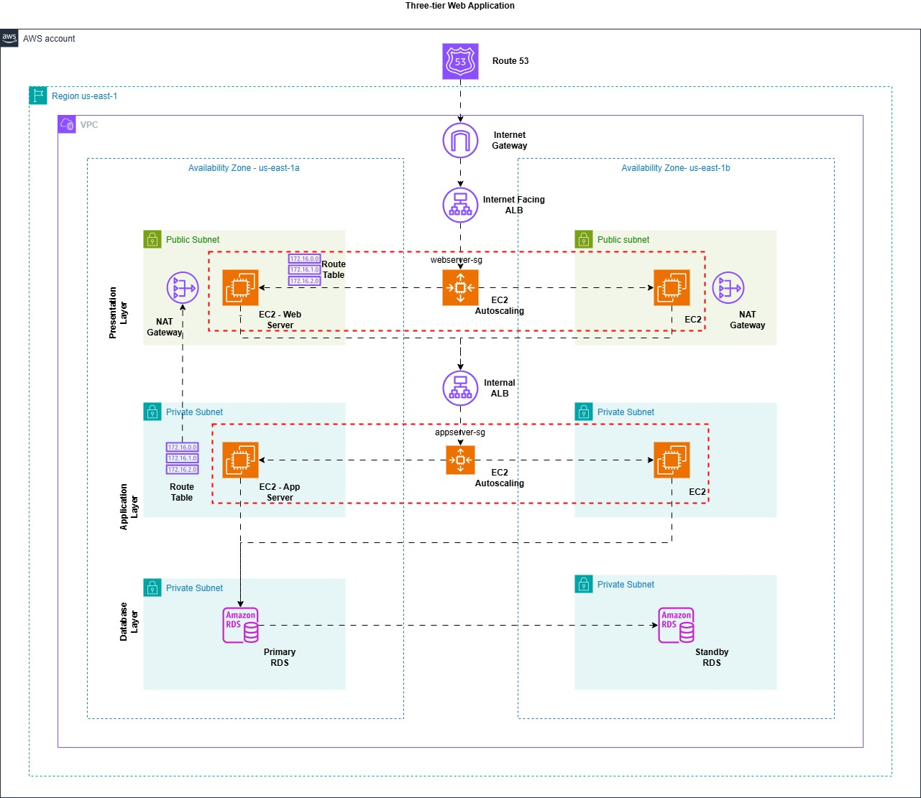

Individual Diagram

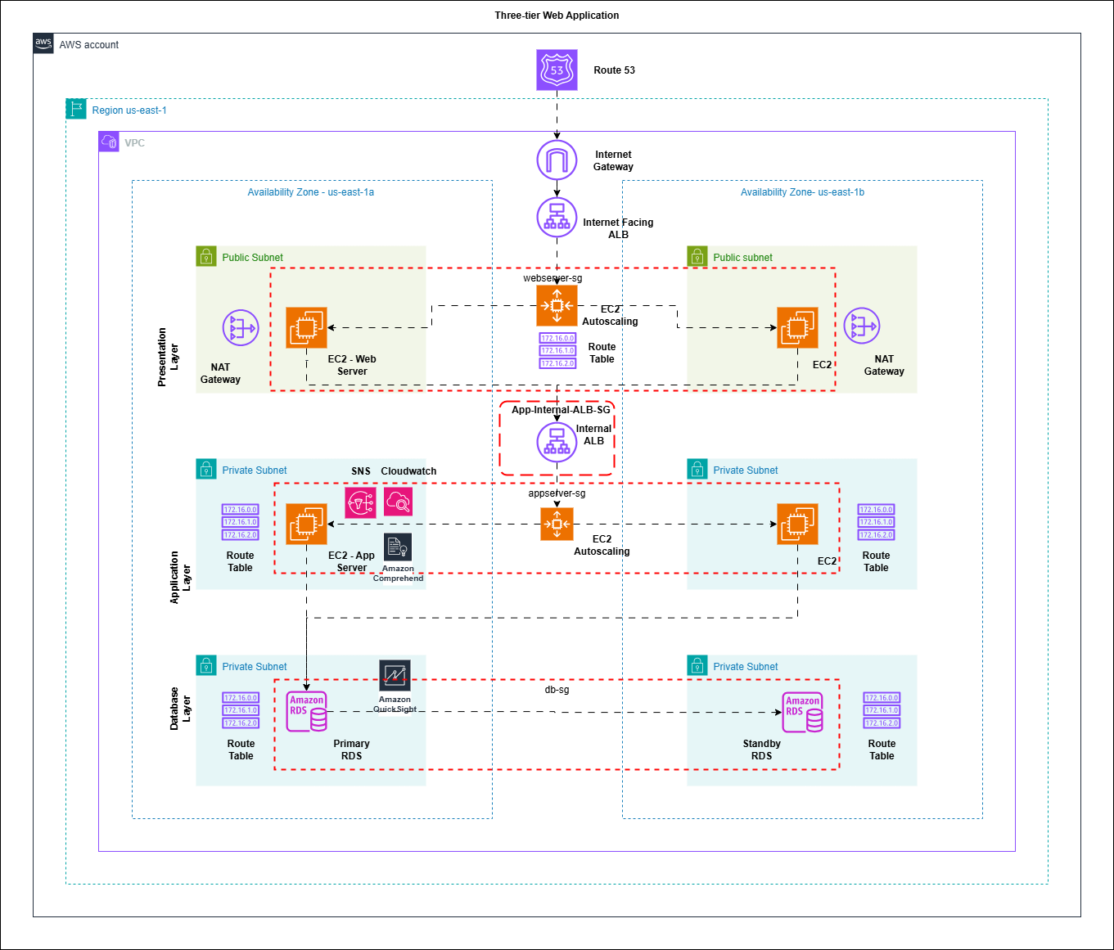

The architecture of the AWS Feedback Management System follows a secure, scalable, and highly available three-tier design:

* Amazon Route 53 – Handles domain name resolution for the feedback system’s public endpoint and directs traffic to the Public ALB.
* Internet Gateway (IGW) – Provides internet connectivity to public subnets for the web tier and ALB.
* Public Application Load Balancer (ALB) – Distributes incoming traffic across web-tier EC2 instances in multiple Availability Zones.
* Web Tier (Public Subnets) –

1. Auto Scaling Group (WebServer-ASG) runs EC2 instances hosting the feedback form frontend.
2. Security Group (webserver-sg) allows HTTP/HTTPS traffic from anywhere and SSH access only from admin IPs.

* Internal Application Load Balancer (Internal ALB) –

1. Routes requests from the web tier to the app tier.
2. Security Group (App-Internal-ALB-SG) allows inbound HTTP only from webserver-sg.

* App Tier (Private Subnets) –

1. Auto Scaling Group (AppServerASG) runs EC2 instances hosting the backend logic that processes feedback, calls AWS Comprehend, and writes to RDS.
2. Security Group (appserversg) allows HTTP only from the Internal ALB SG.

* Database Tier (Private Subnets) –

1. Amazon RDS MySQL for storing data and analysis data.
2. Security Group (dbsg) allows MySQL access only from appserversg.

* NAT Gateways – Allow private-tier EC2 instances (app and DB layers) to reach the internet for OS updates and package installations without public exposure.
* Route Tables – Separate public and private routes, directing internet traffic via the IGW and private subnet traffic via NAT Gateways.

# AWS Resource

The AWS Feedback Management System is deployed using the following AWS services and components:

* Amazon VPC – Provides an isolated virtual network for hosting all application components securely.
* Public and Private Subnets – Public subnets host web-tier EC2 instances and load balancers, while private subnets host the application-tier EC2 and RDS.
* Internet Gateway (IGW) – Enables public internet access for frontend servers and public ALB.
* NAT Gateways – Allow private subnets to access the internet for system updates without exposing them.
* Route Tables – Manage traffic flow between subnets, IGW, and NAT Gateways.
* Security Groups – Restrict inbound and outbound traffic for each component (web, app, DB, ALBs) using least-privilege principles.
* Public Application Load Balancer (ALB) – Routes external HTTP traffic to healthy web-tier EC2 instances.
* Internal Application Load Balancer (Internal ALB) – Routes traffic from the web tier to the app tier securely.
* Target Groups – Manage EC2 instance registration for load balancers and perform health checks.
* EC2 Auto Scaling Groups – Dynamically scale EC2 instances for web and app tiers based on CPU utilization and request load.
* Amazon EC2 – Web tier serves the frontend feedback form, and the app tier processes submissions, calls AWS Comprehend, and stores data in RDS.
* Amazon RDS (MySQL) – Managed database storing feedback submissions and sentiment results.
* AWS Comprehend – Analyzes feedback text to determine sentiment (Positive, Negative, Neutral, Mixed).
* Amazon QuickSight – Visualizes sentiment analysis and feedback trends through interactive dashboards.
* Amazon CloudWatch – Monitors application performance, collects logs, and sends alerts based on configured alarms.
* Amazon SNS – Sends notifications when Auto Scaling events occur, such as launching or terminating EC2 instances.

# Implementation Steps

Networking Setup

* In the AWS Management Console, open the VPC service and create a VPC with CIDR block 10.0.0.0/16. Enable DNS hostnames and DNS resolution.
* Create 6 subnets:
* Create and attach an Internet Gateway (IGW) to the VPC to allow public internet access for public subnets.
* Create NAT Gateways in each public subnet to provide outbound internet access for private subnets without exposing them publicly.
* Create Route Tables

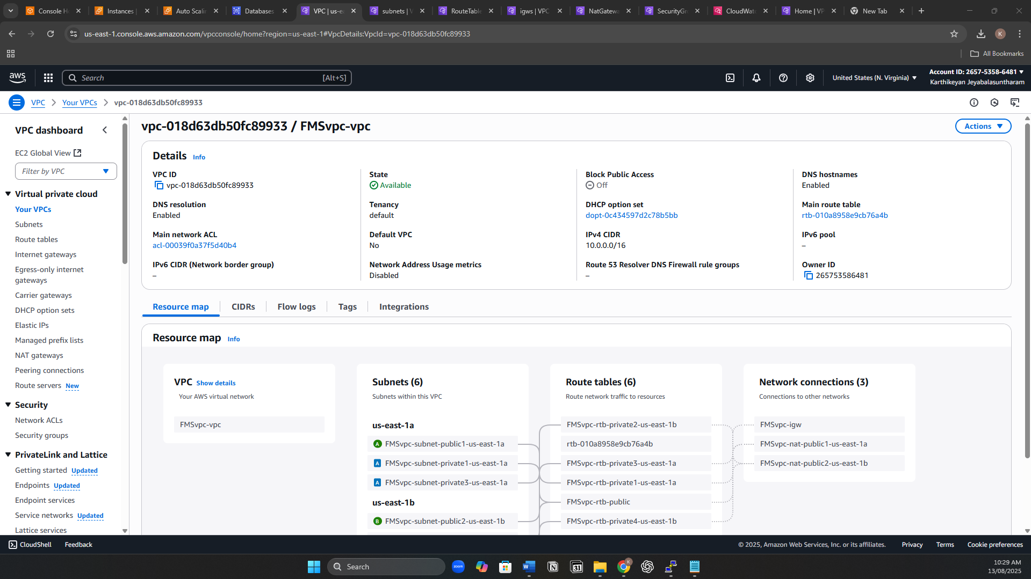

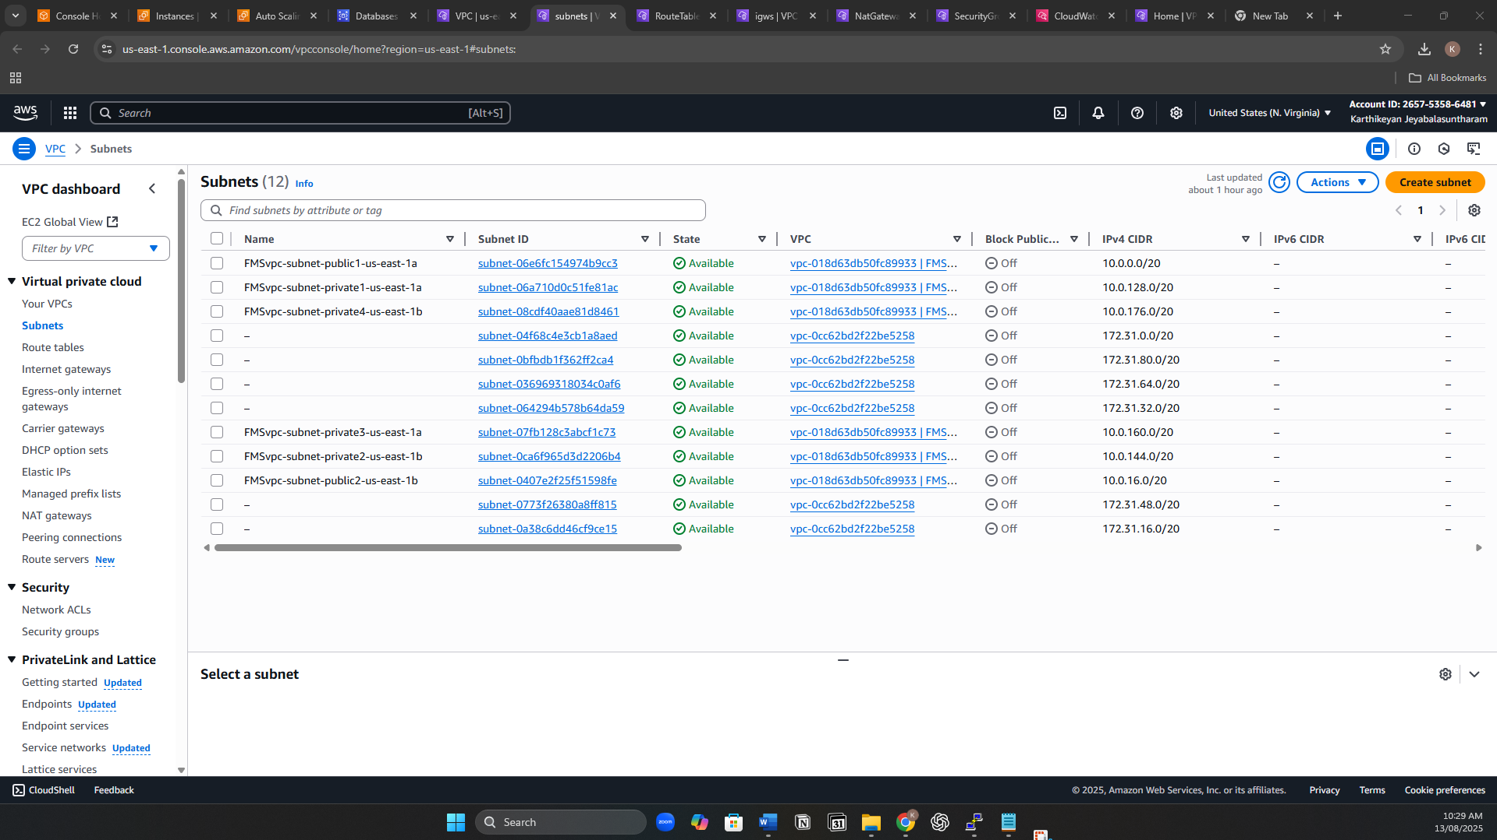

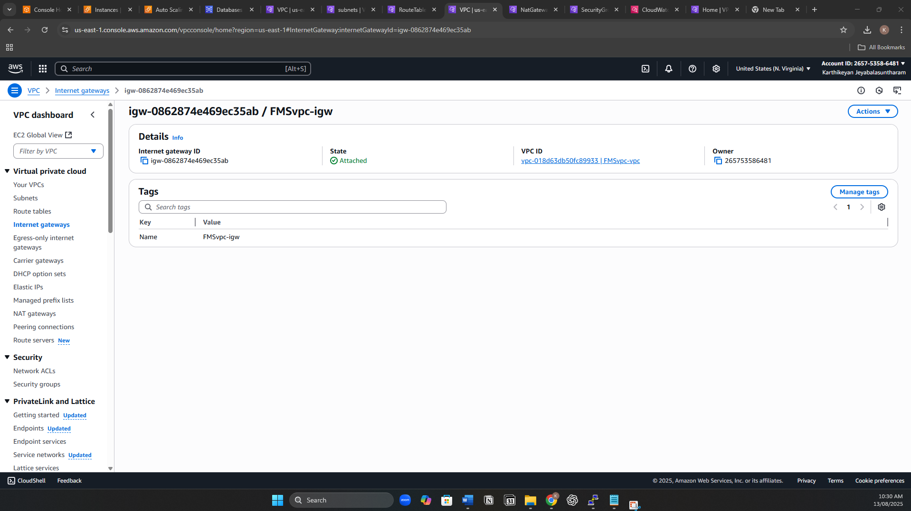

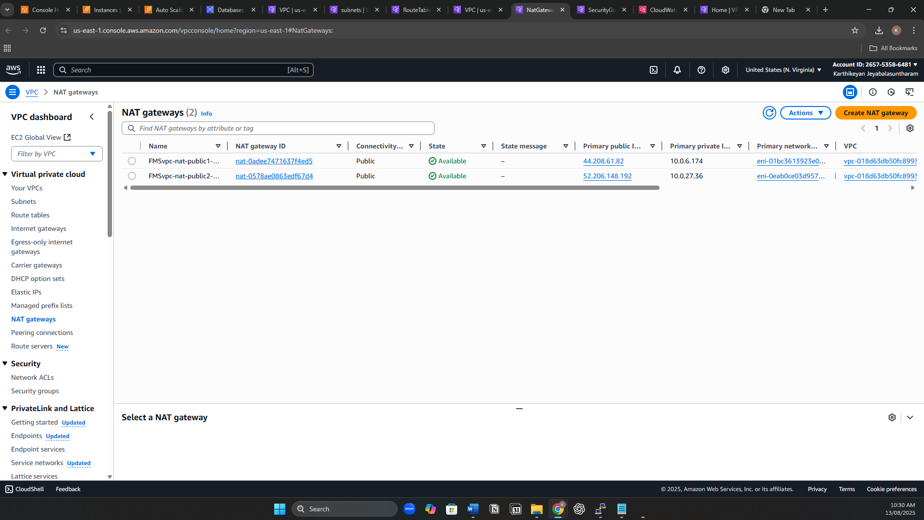

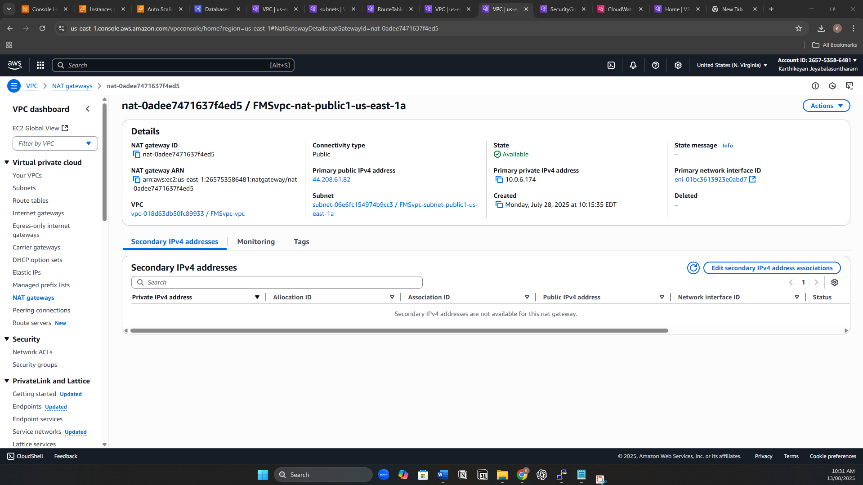

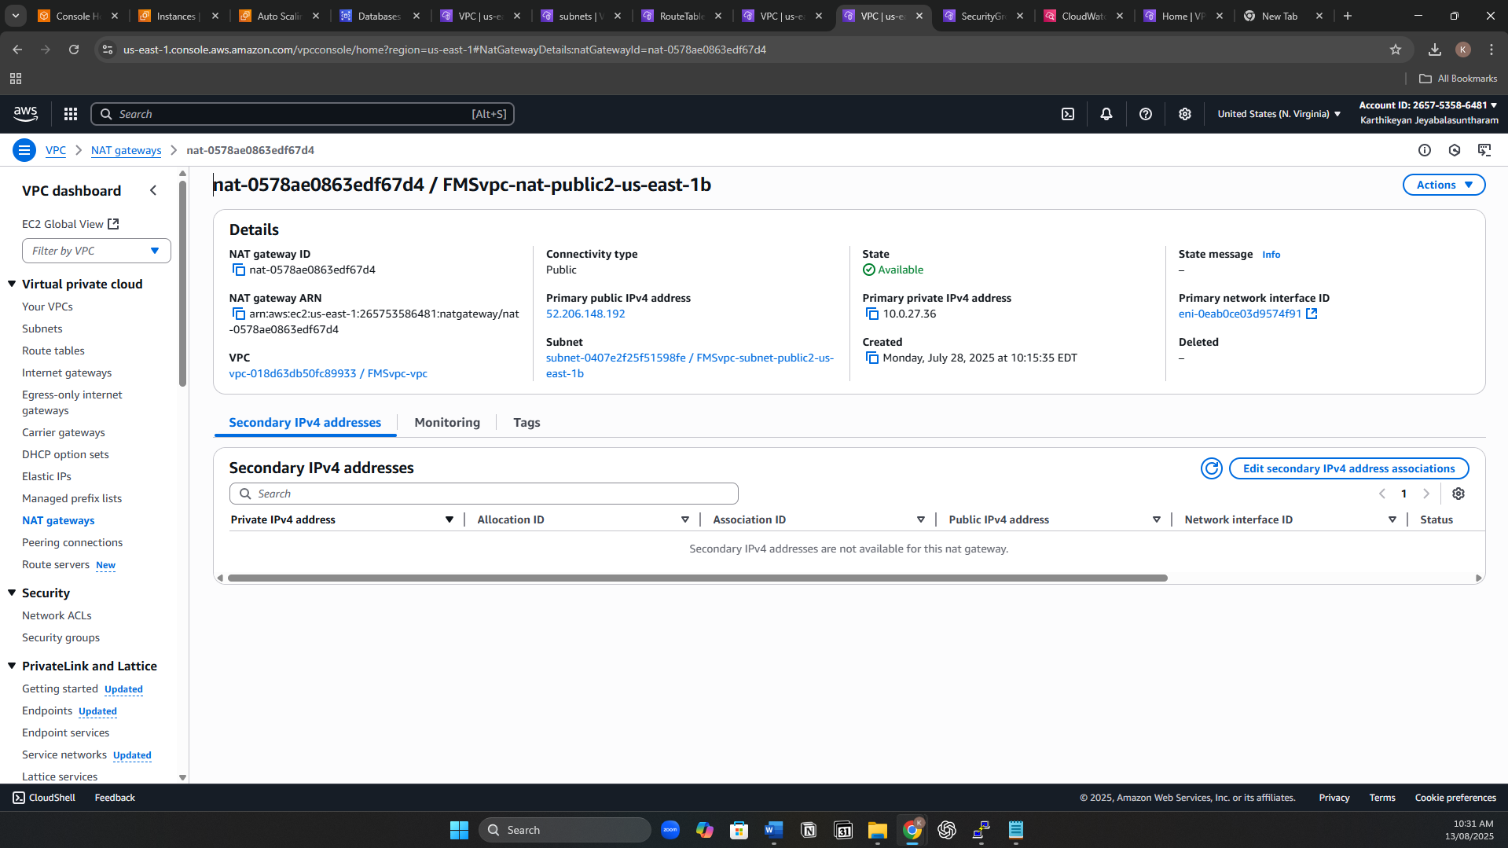

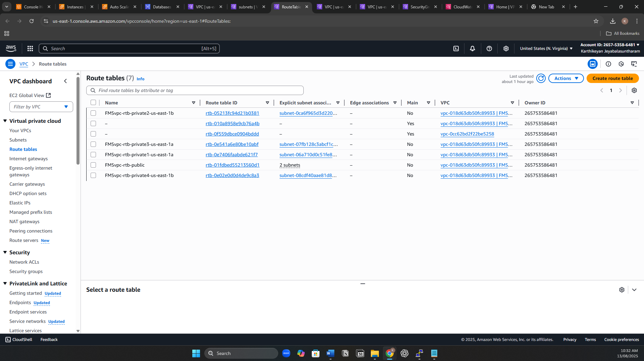

Security Configuration

**Security Groups**

* Create WebServerSG:
  + Inbound: Allow HTTP (80), SSH (22) and HTTPS (443) from 0.0.0.0/0.
  + Outbound: Allow all traffic (default).
* Create AppServerSG:
  + Inbound: Allow SSH (22) and Custom TCP(5000) from WebServerSG.
  + Outbound: Allow all traffic (default).
* Create DBSG, DbAnalysisSG:
  + Inbound: Allow MySQL (3306) from AppServerSG.
  + Outbound: Allow all traffic (default).
* Create ALB security group:
  + Internal ALB-SG: Allow HTTP(80) from WebServerSG only.

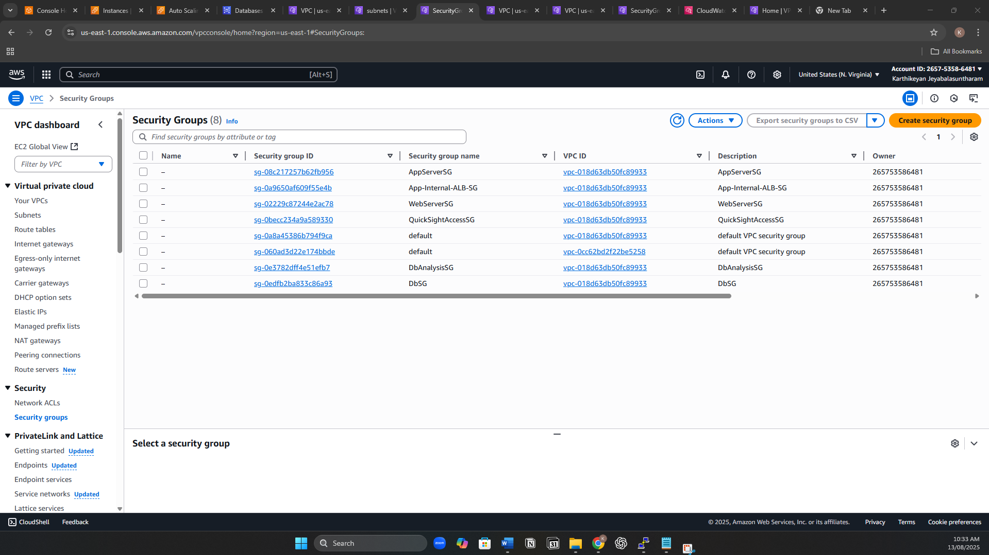

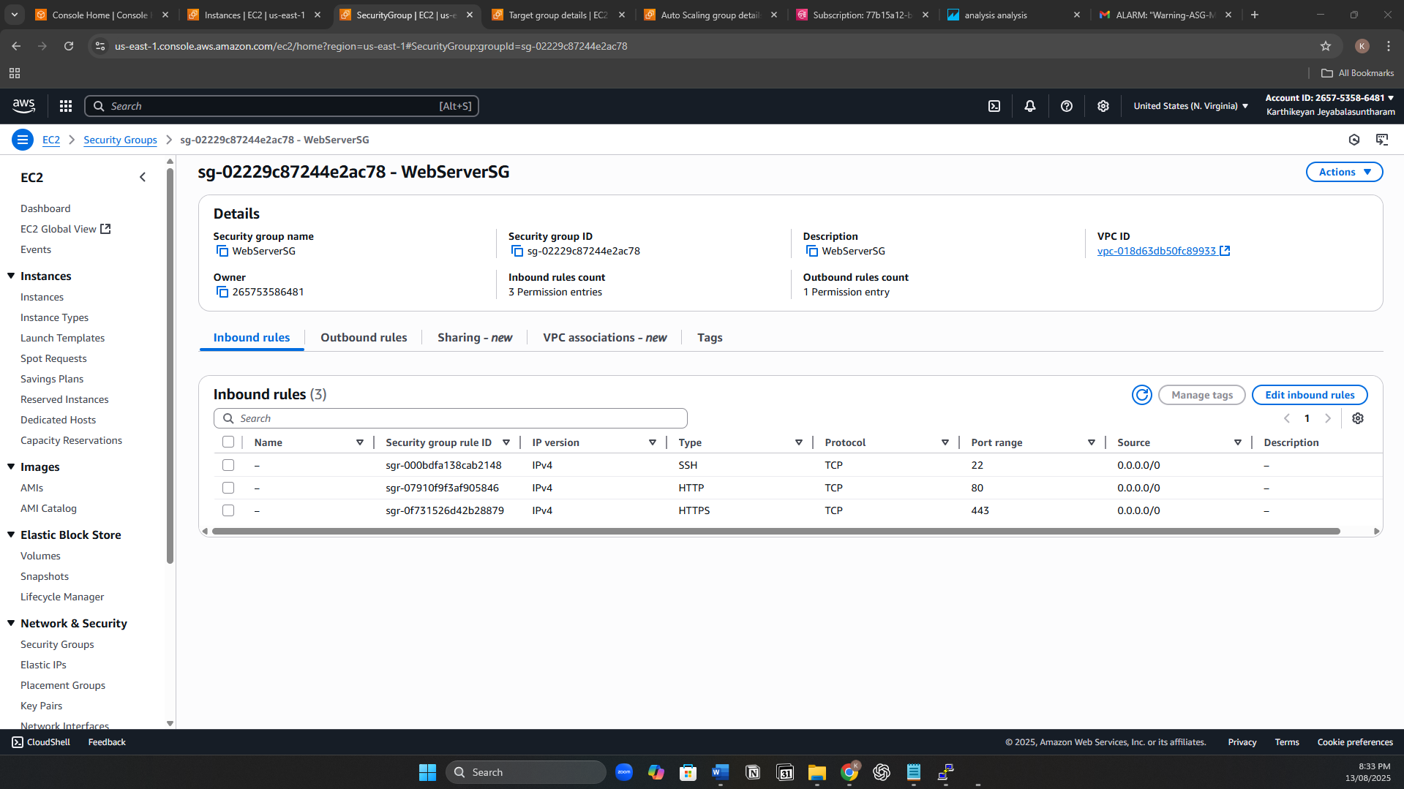

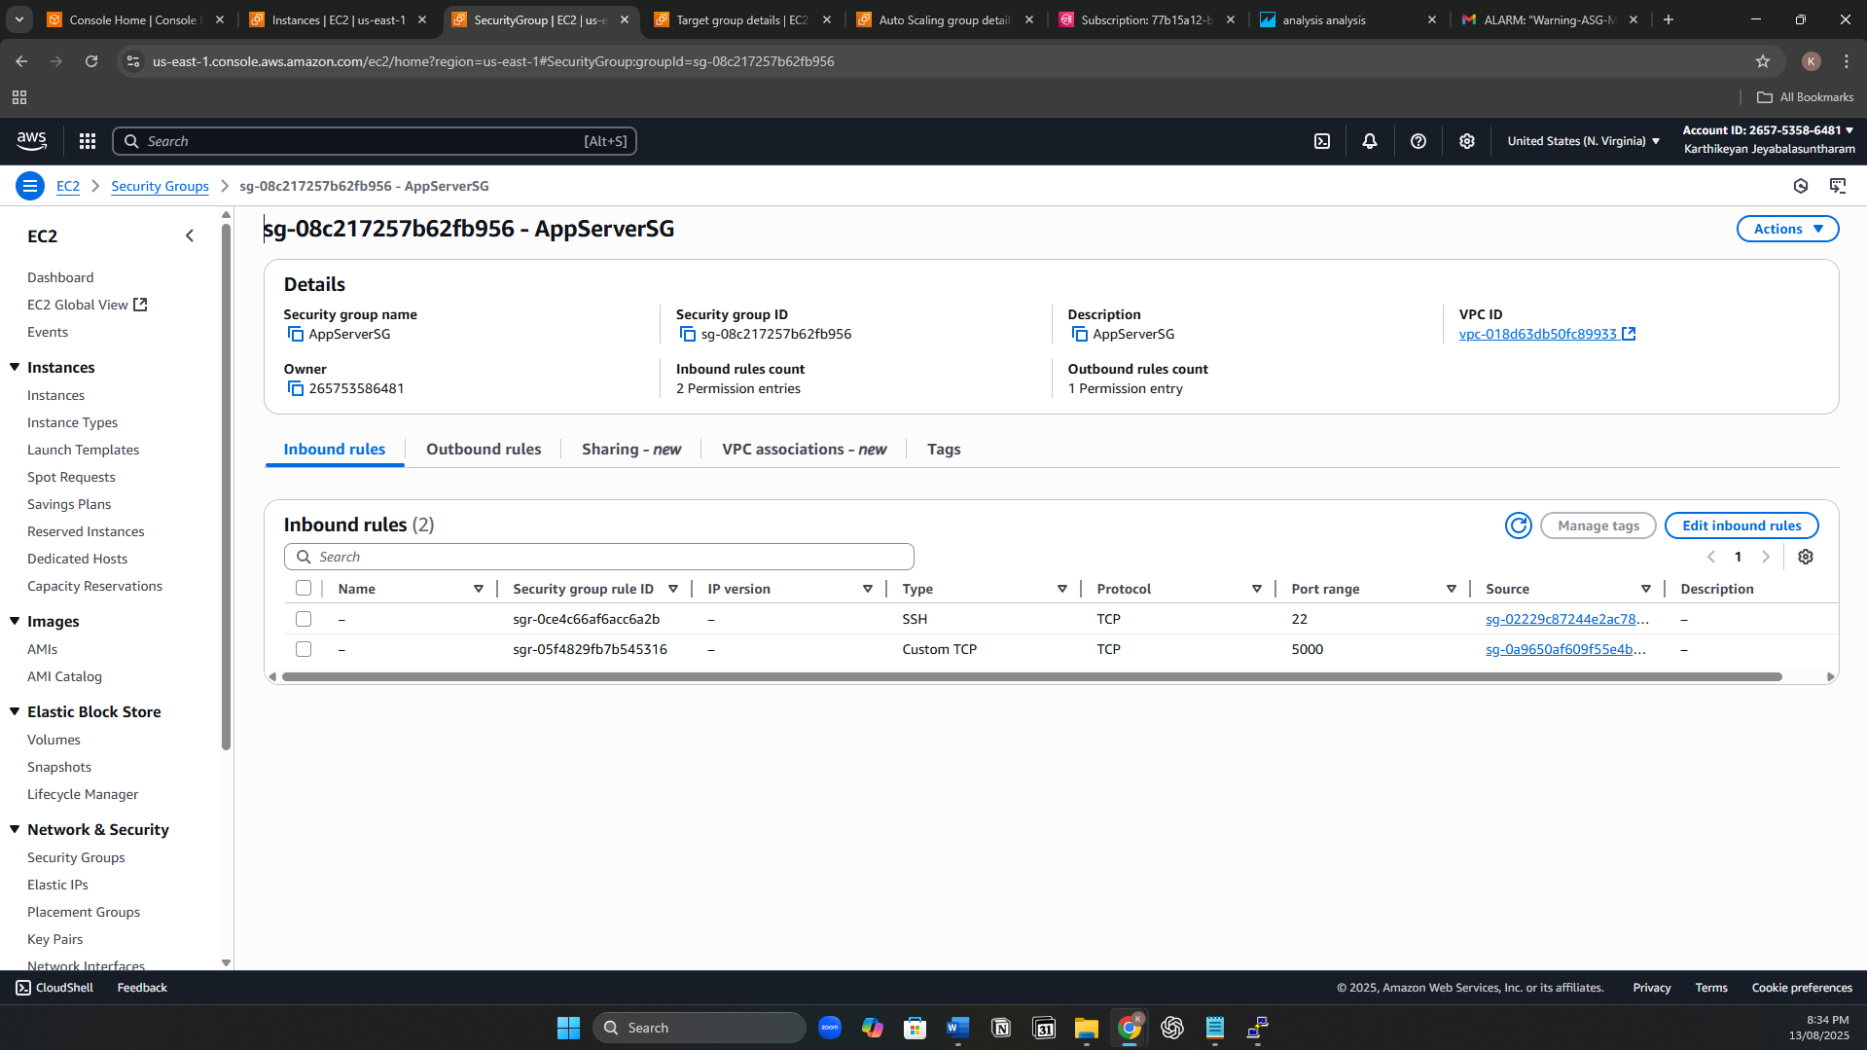

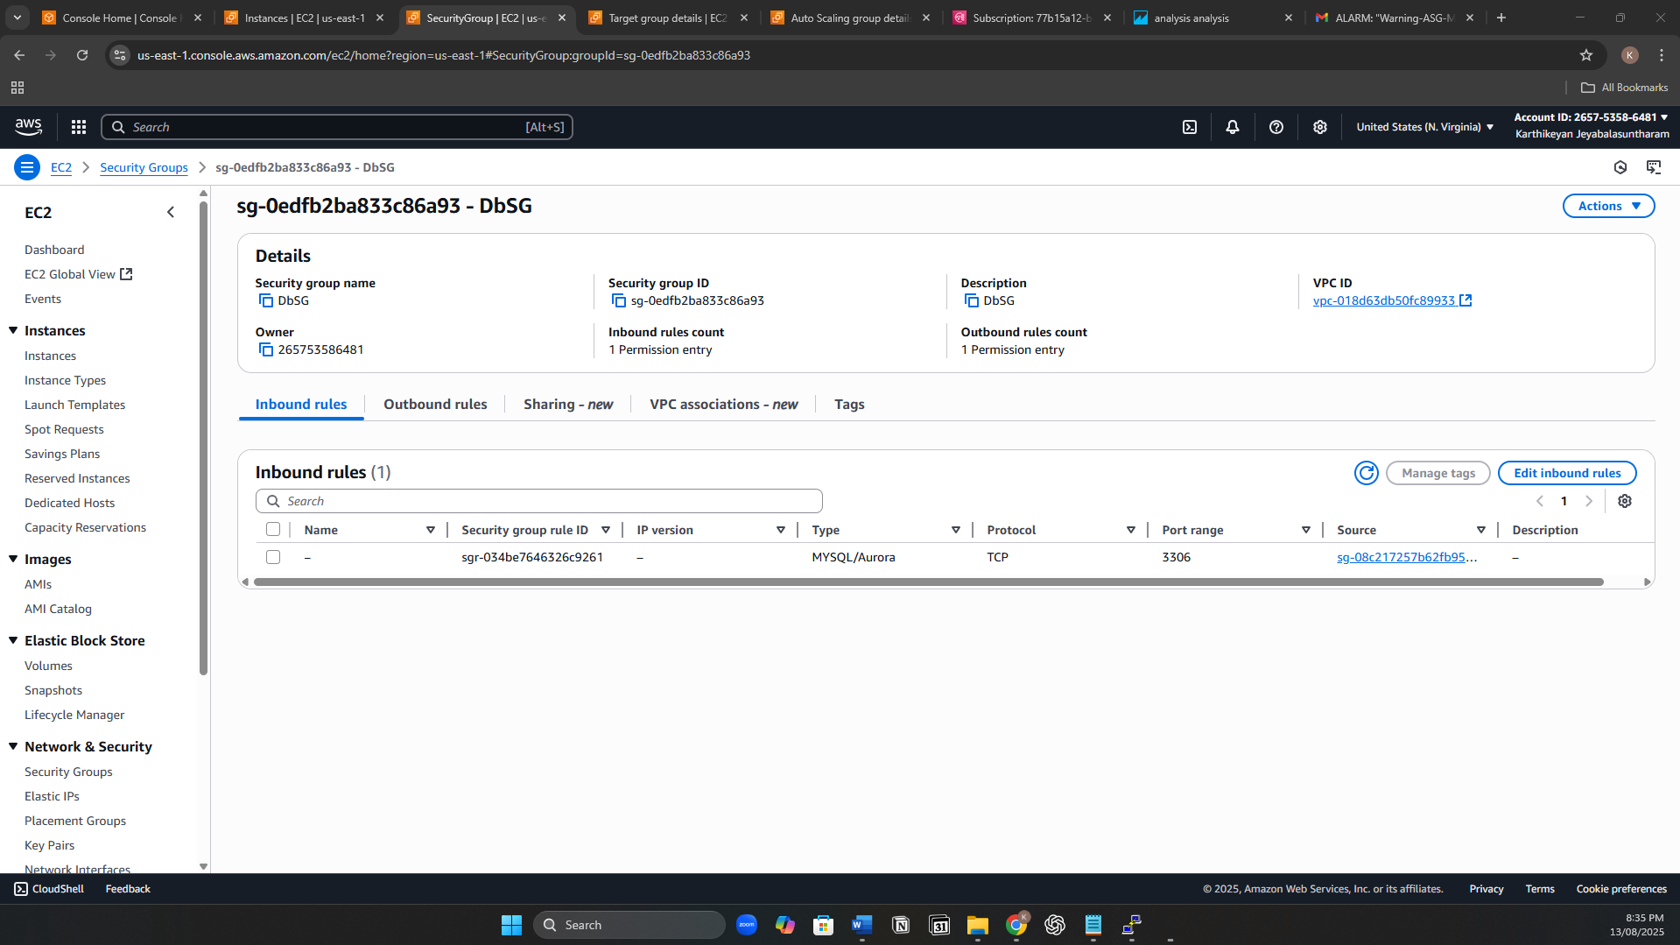

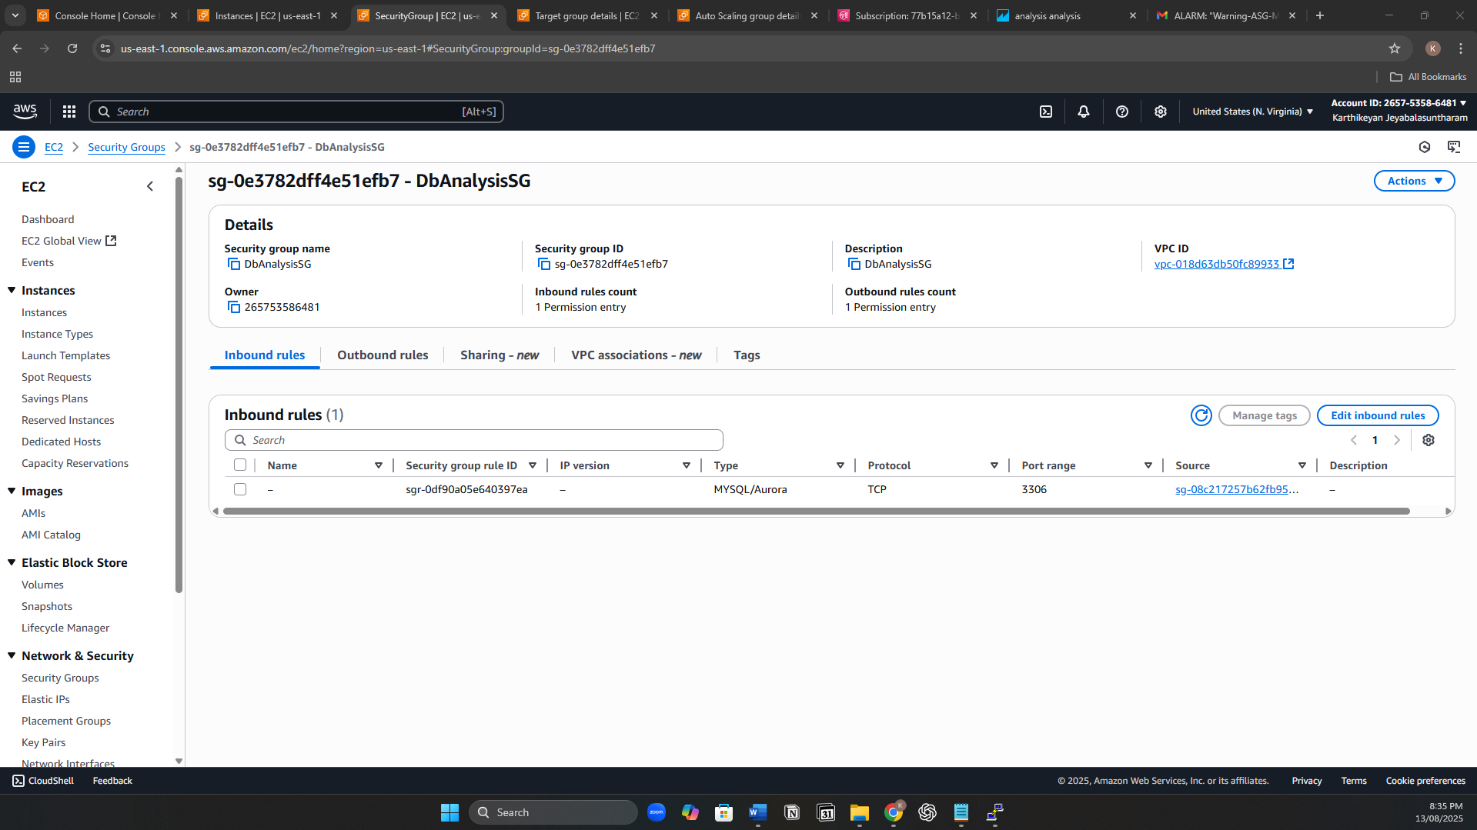

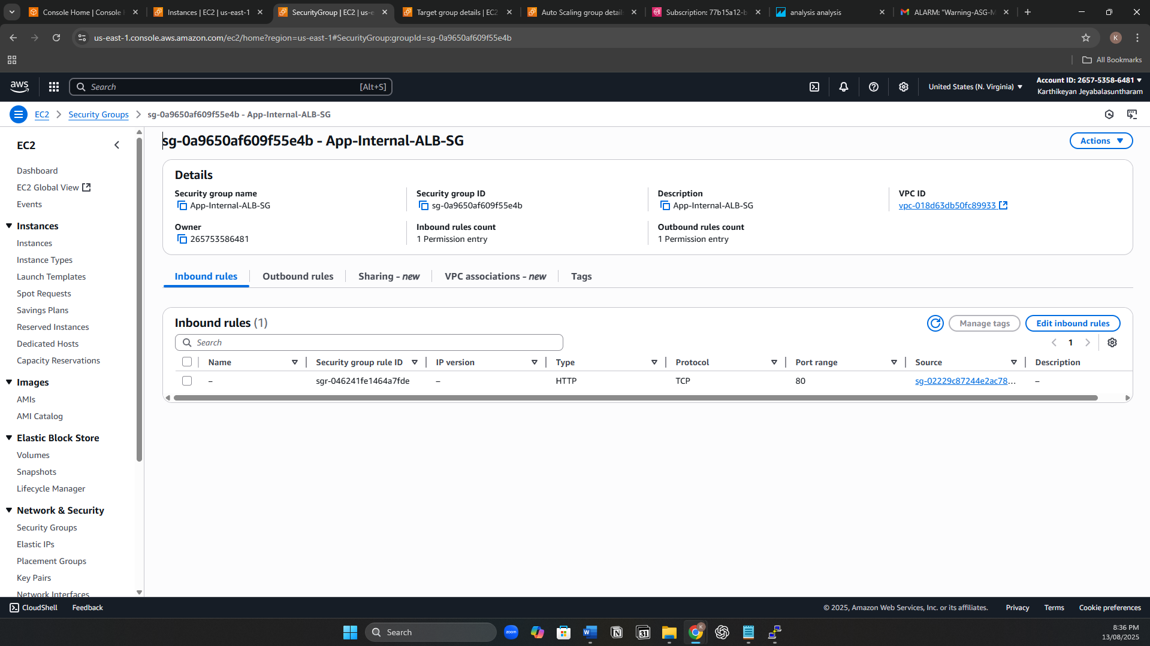

Web & App Deployment

* Launch EC2 instances in the Web Tier (public subnets) using Amazon Linux 2023. Assign WebServer-SG.
* Install Apache web server and configure it to serve the frontend feedback form.
* Launch EC2 instances in the App Tier (private subnets) using Amazon Linux 2023. Assign AppServer-SG.
* Install Python3, Flask, MySQL-Connector, and Boto3 for AWS Comprehend integration.
* Deploy the feedback application code to /home/ec2-user/feedback-app.
* Create feedback-app.service systemd unit file to start the app automatically on boot
* Enable and start the service:

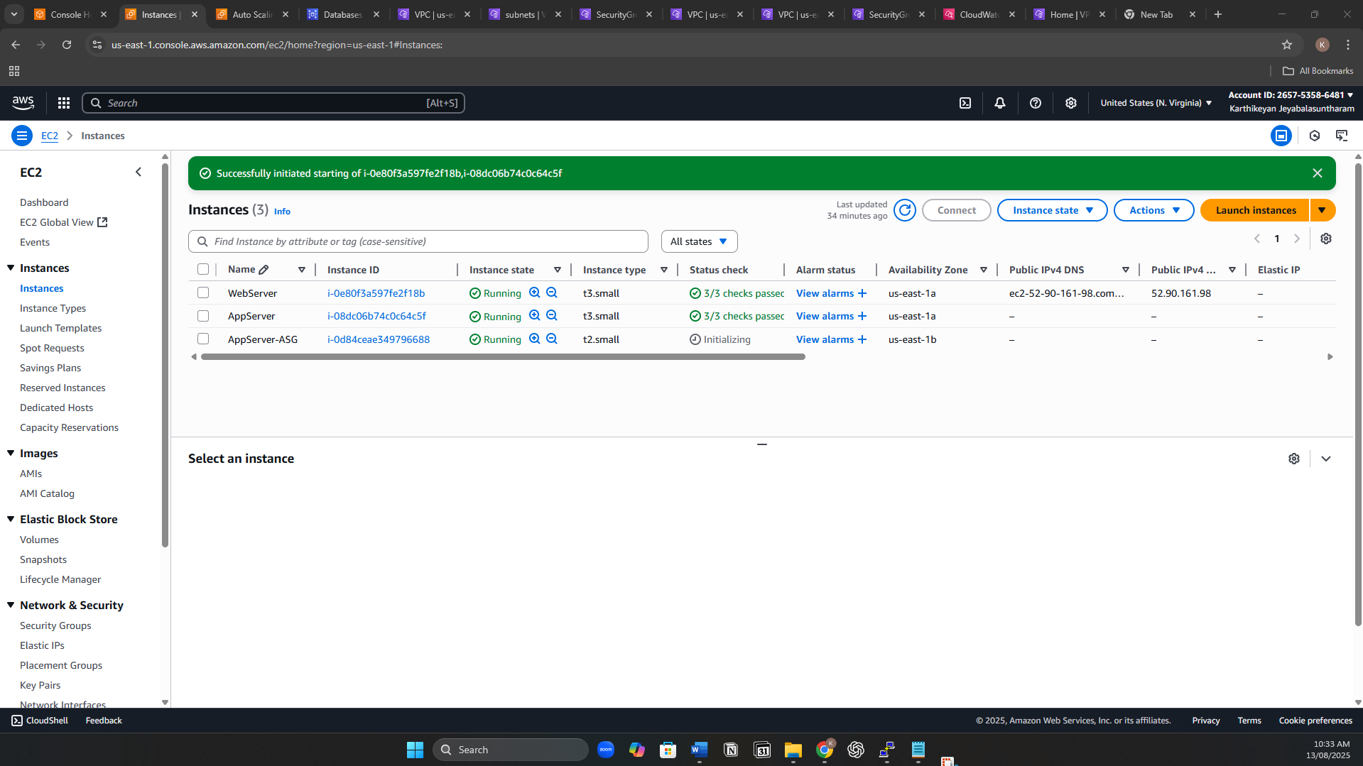

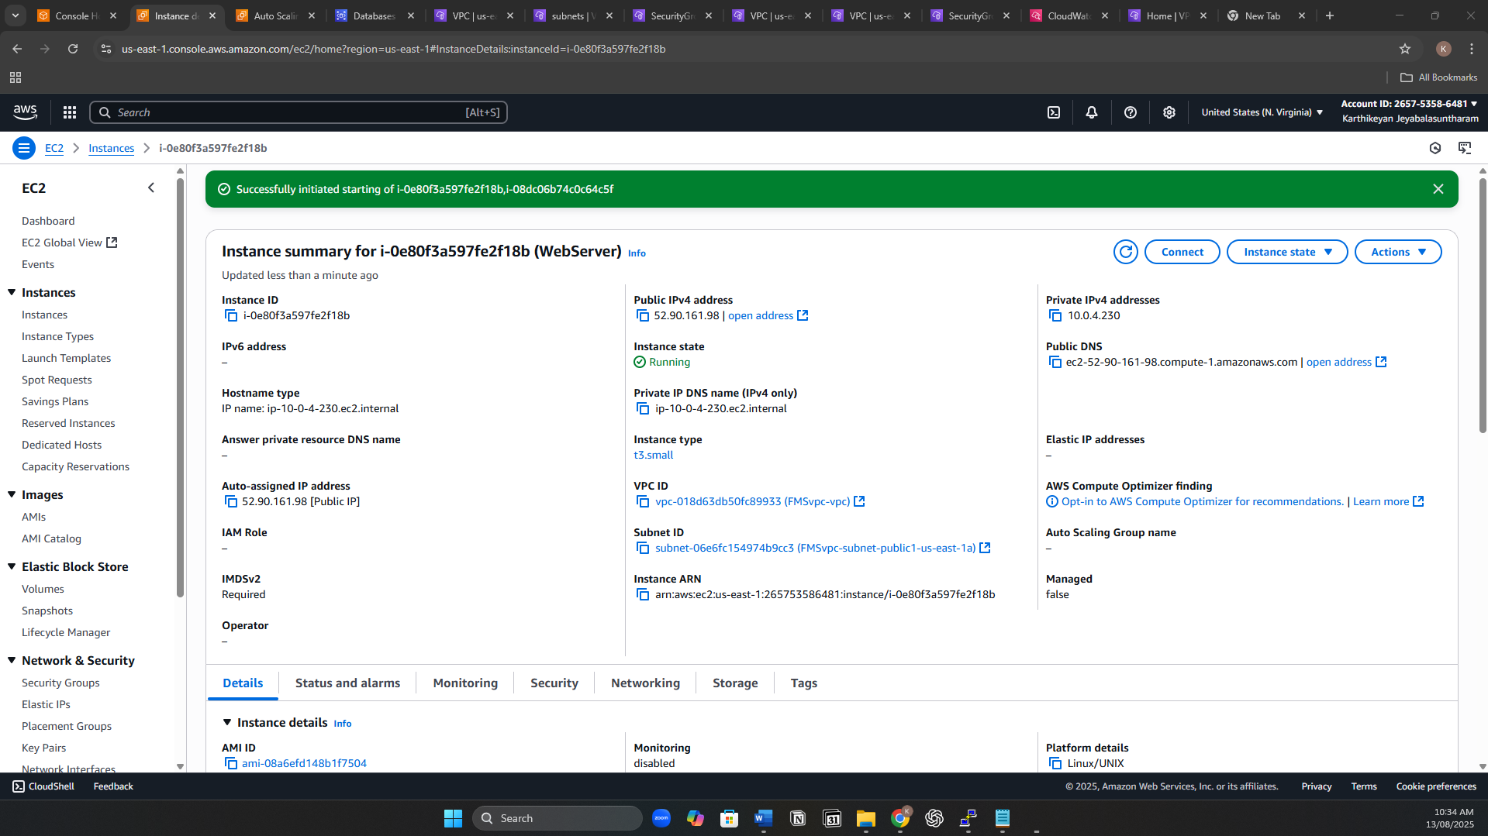

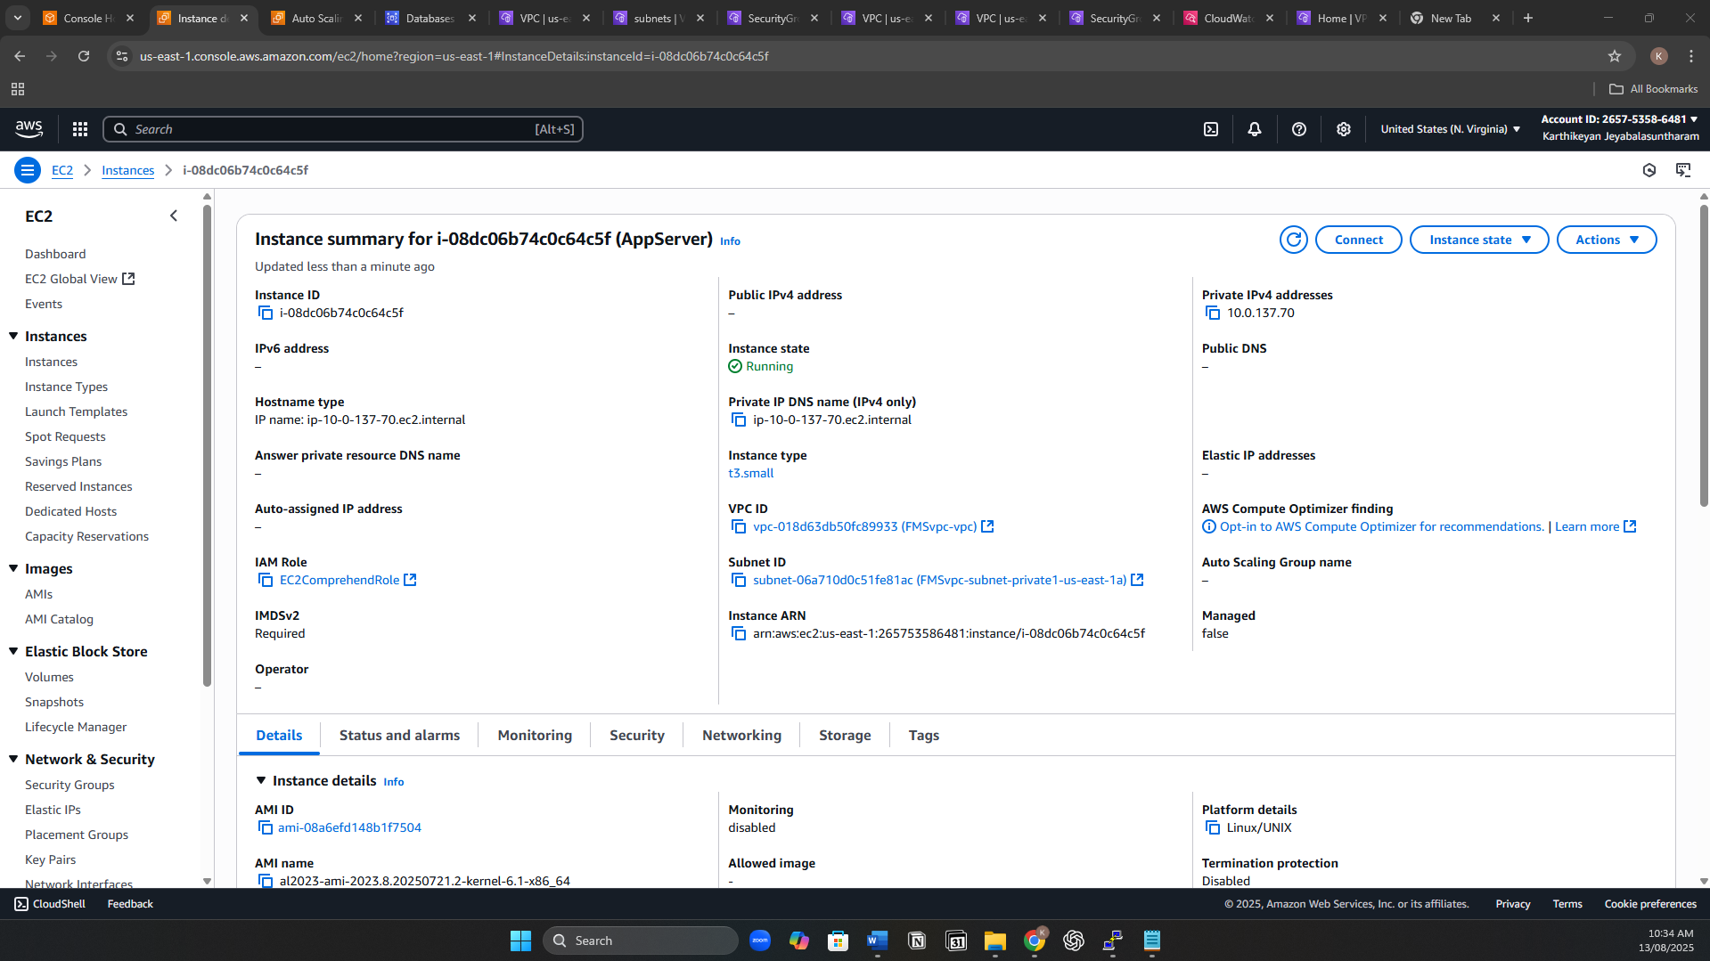

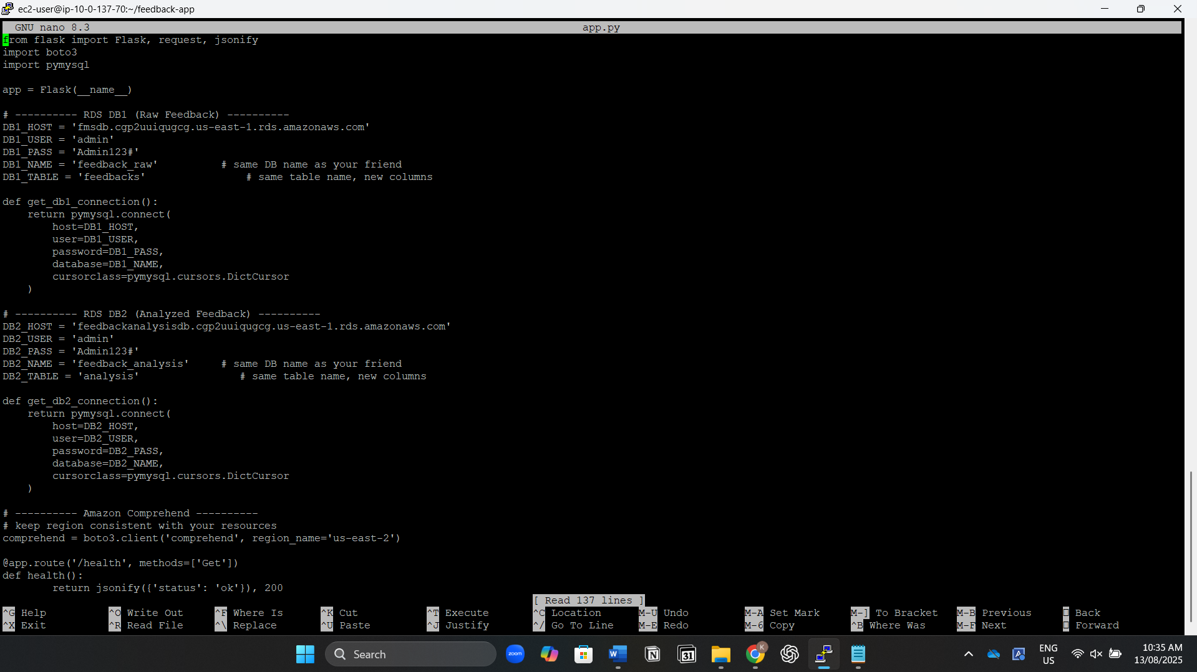

Load Balancing

* Create a Public Application Load Balancer for Web Tier.
* Create an Internal Application Load Balancer App Tier.
* Register target groups.

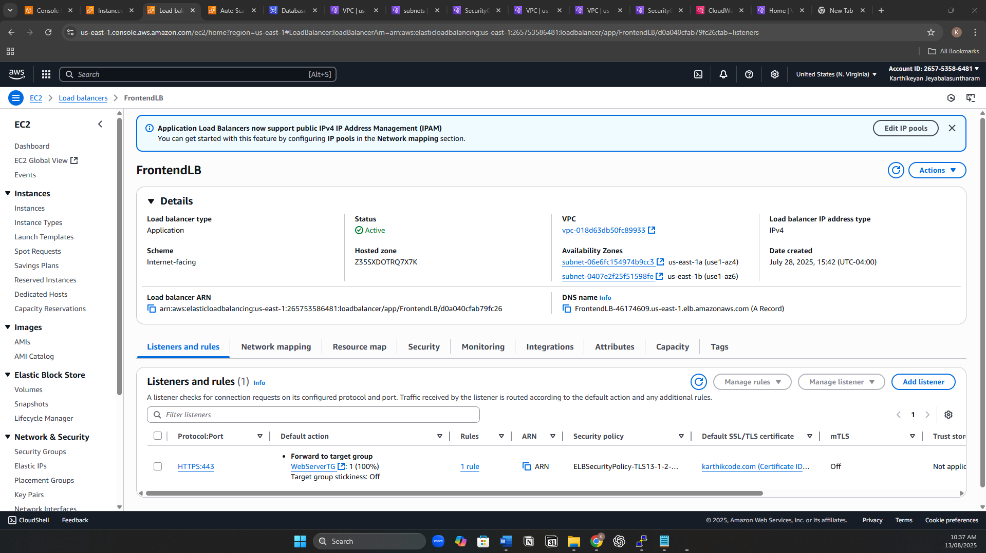

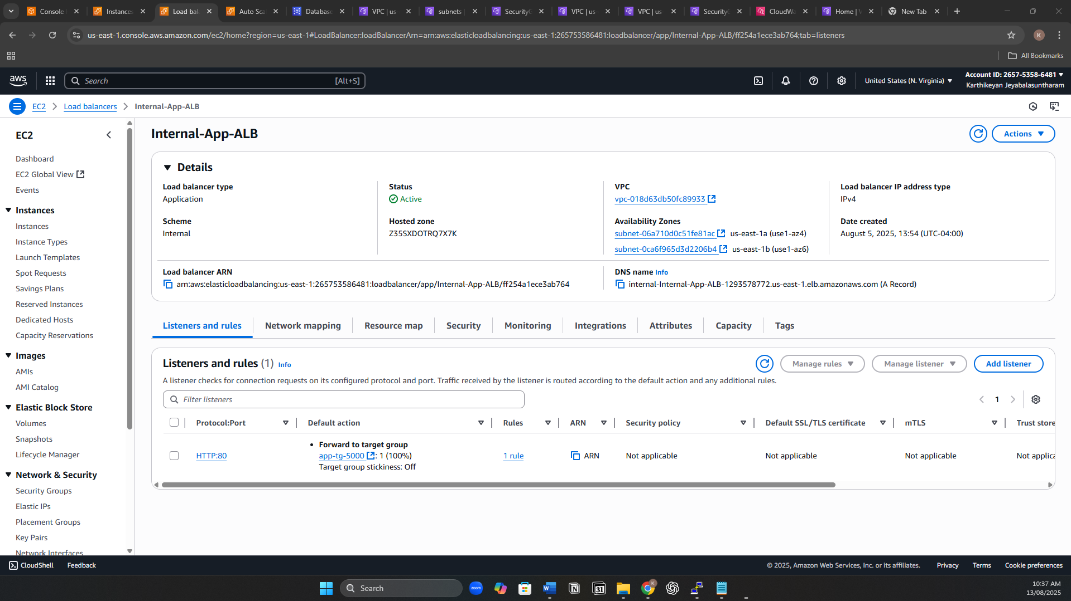

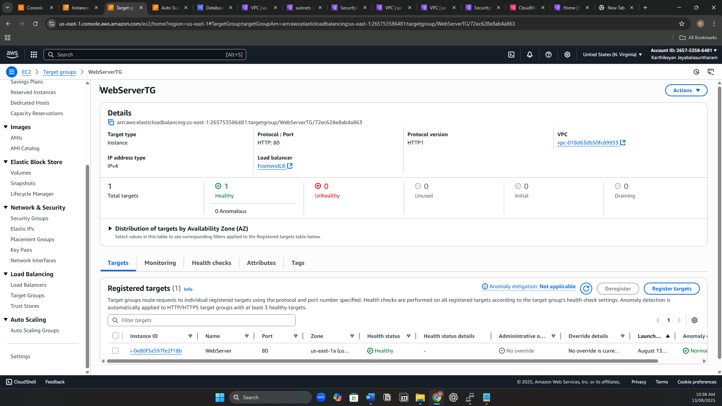

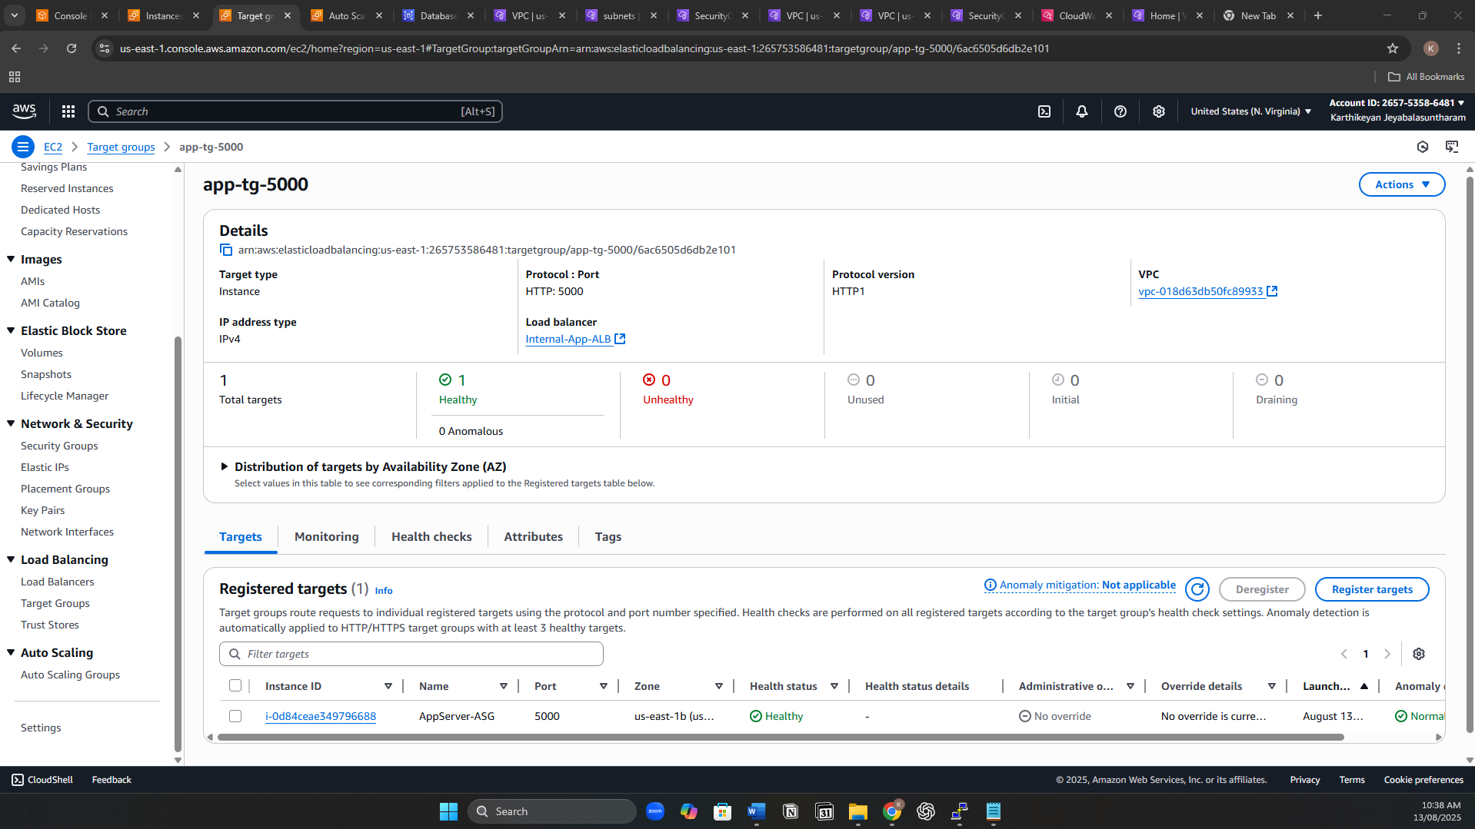

Auto Scaling

* Create Launch Templates for both Web Tier and App Tier:
  + Specify AMI, instance type, key pair, security group, and user data to install packages and deploy app.
* Create Auto Scaling Groups:
  + WebServer-ASG: Public subnets, attach Web Tier target group.
  + AppServer-ASG: Private app subnets, attach App Tier target group.
* Configure scaling policies:
  + Target tracking based on average CPU utilization.
* Enable notifications:
  + Create an Amazon SNS topic for Auto Scaling events.
  + Subscribe with email.
  + Attach SNS topic to the ASG notifications for instance launch/terminate events.

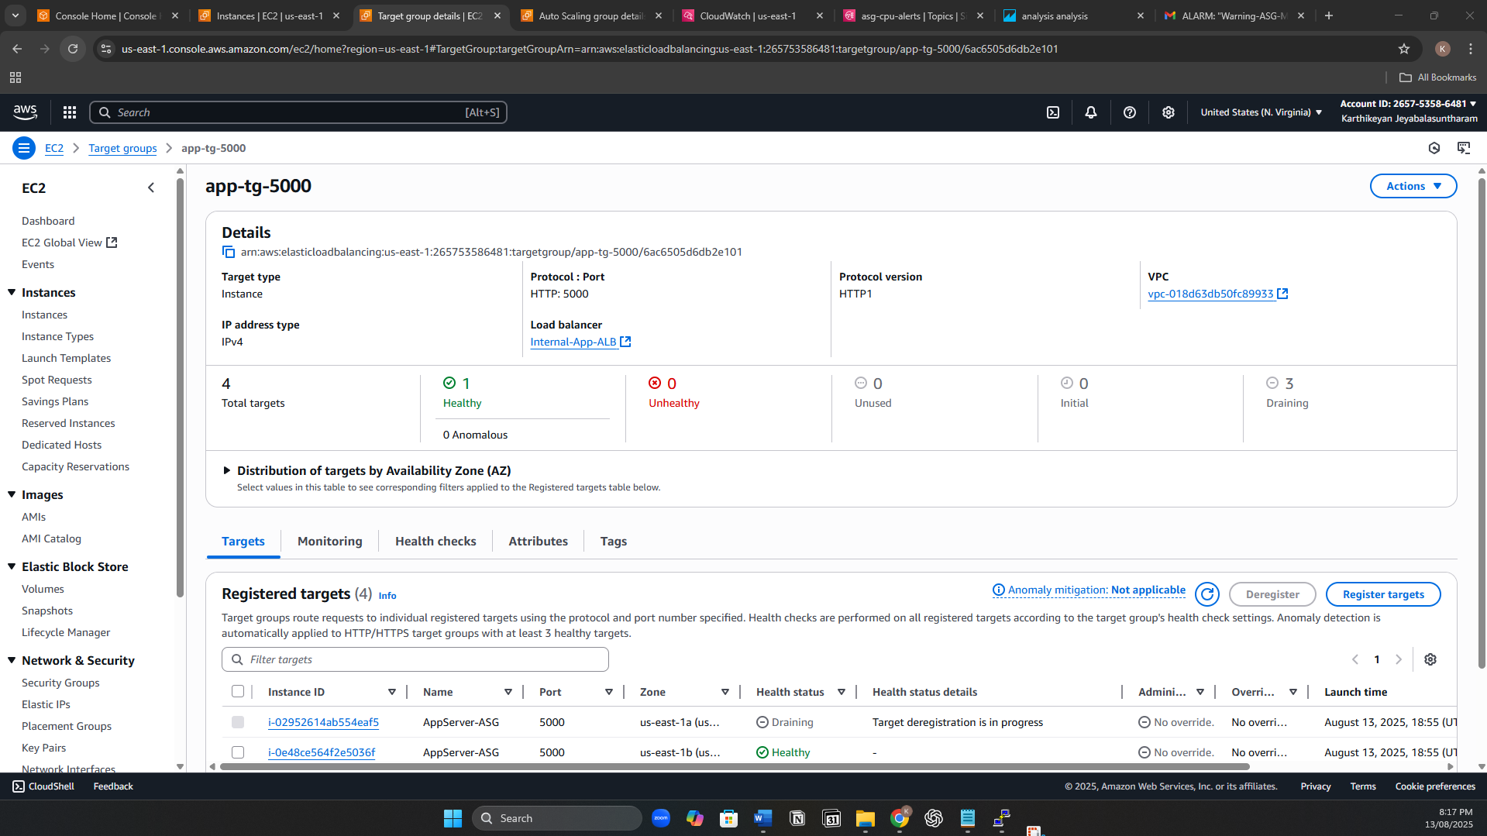

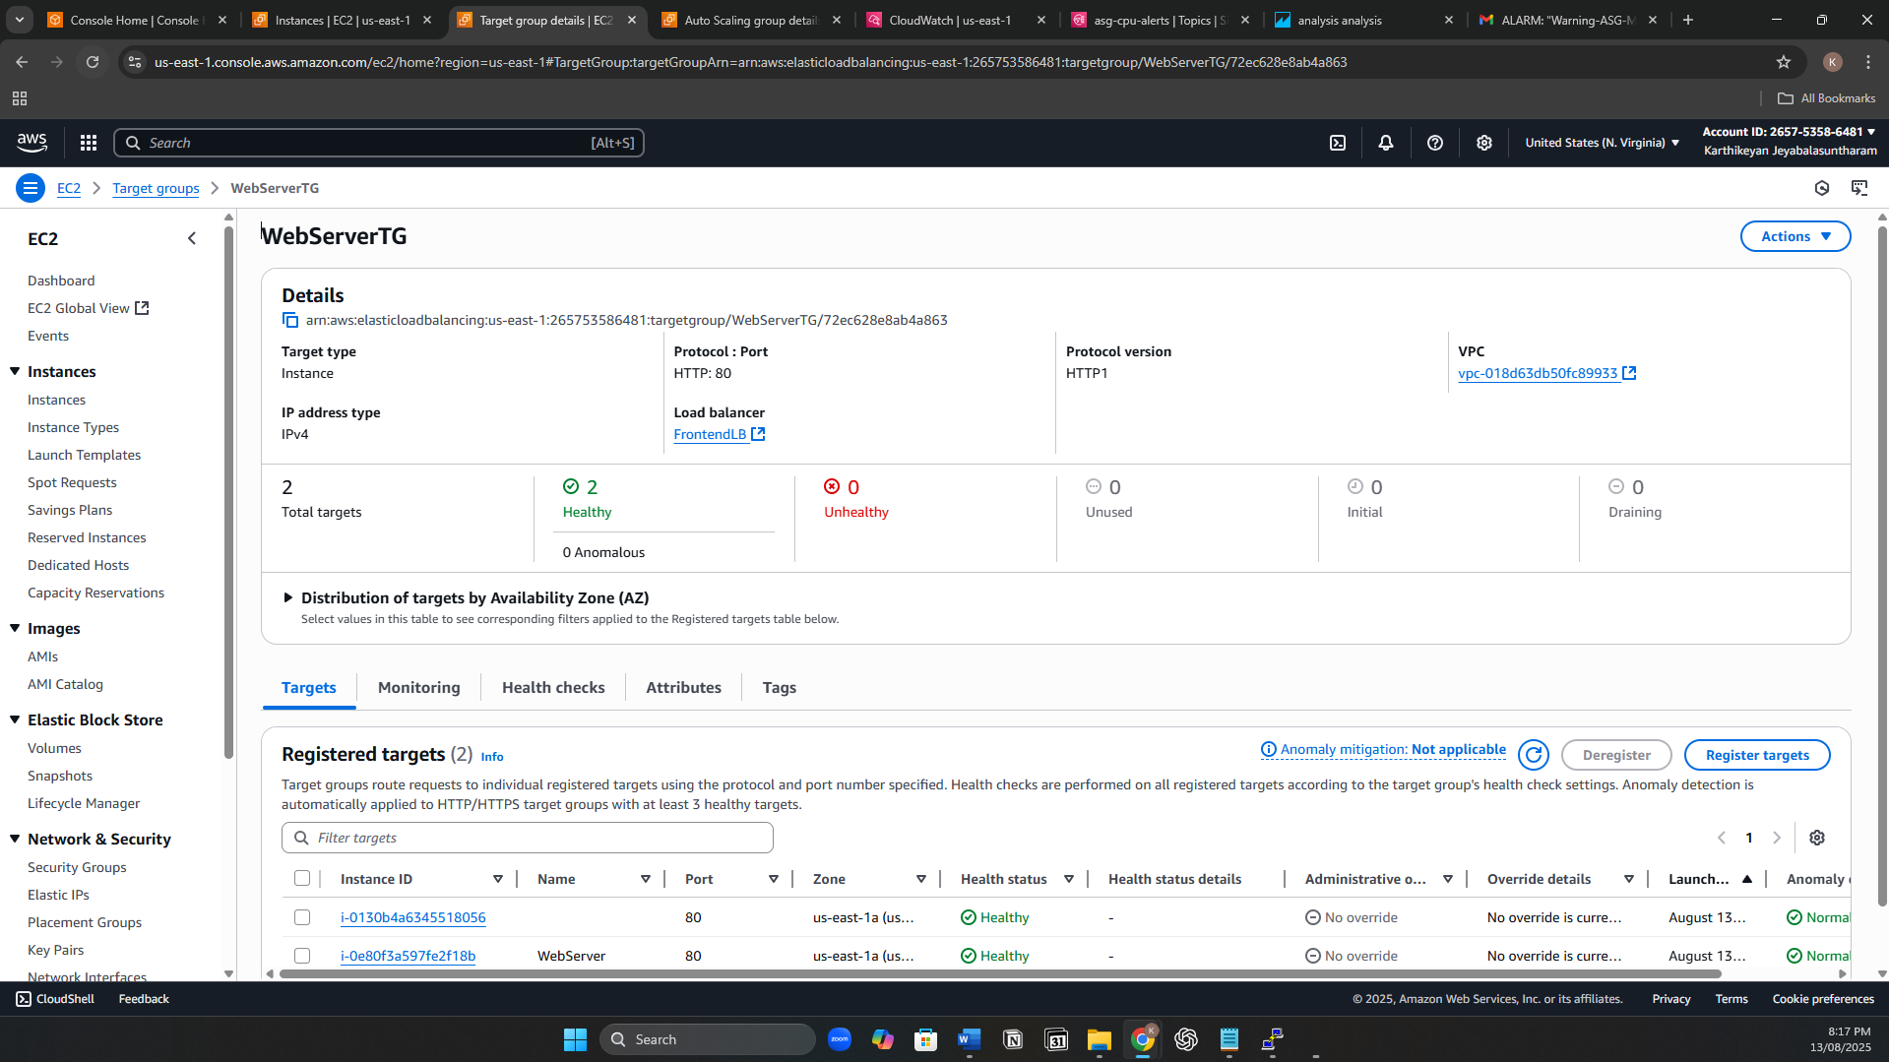

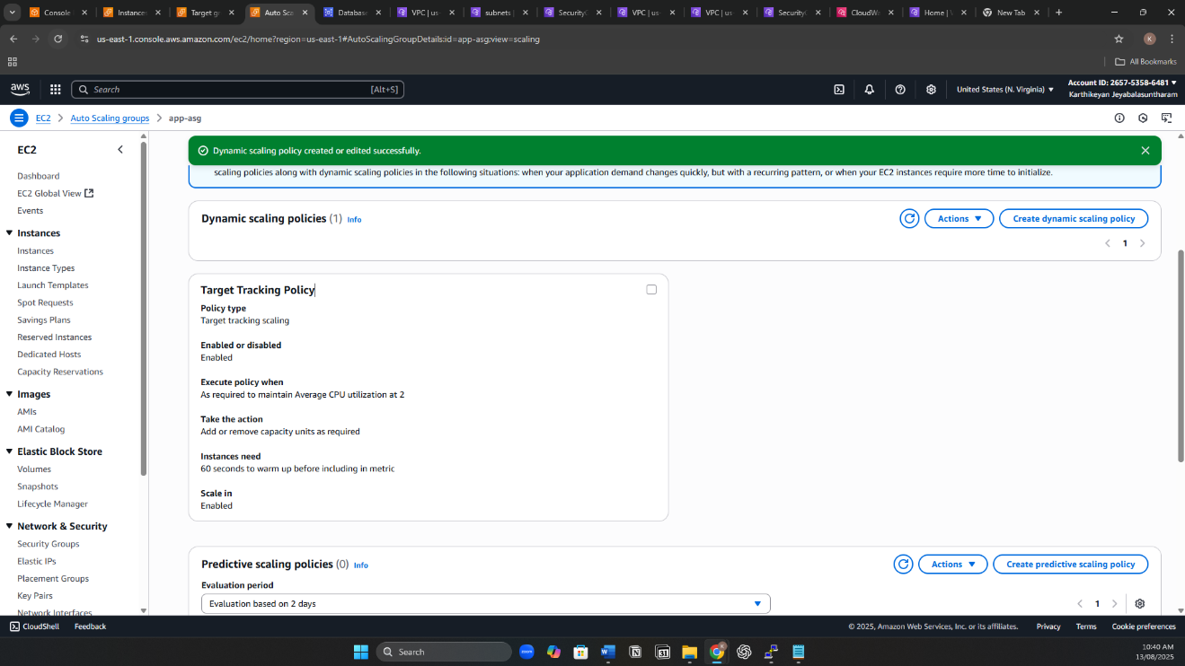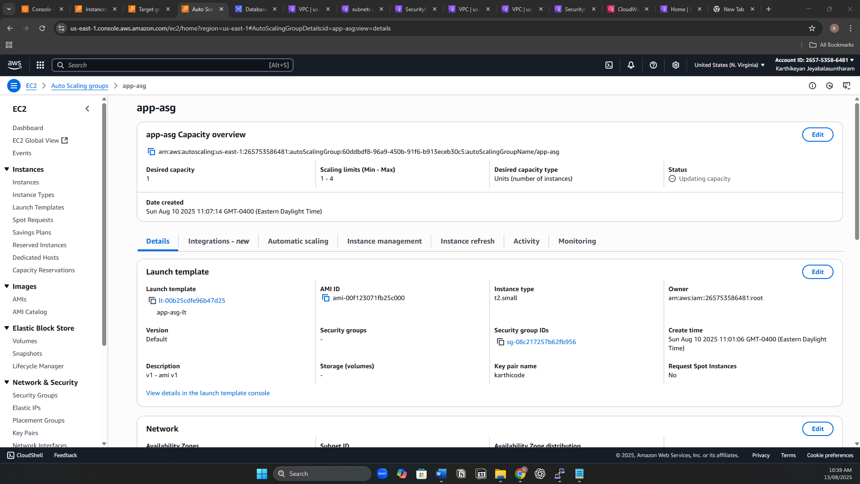

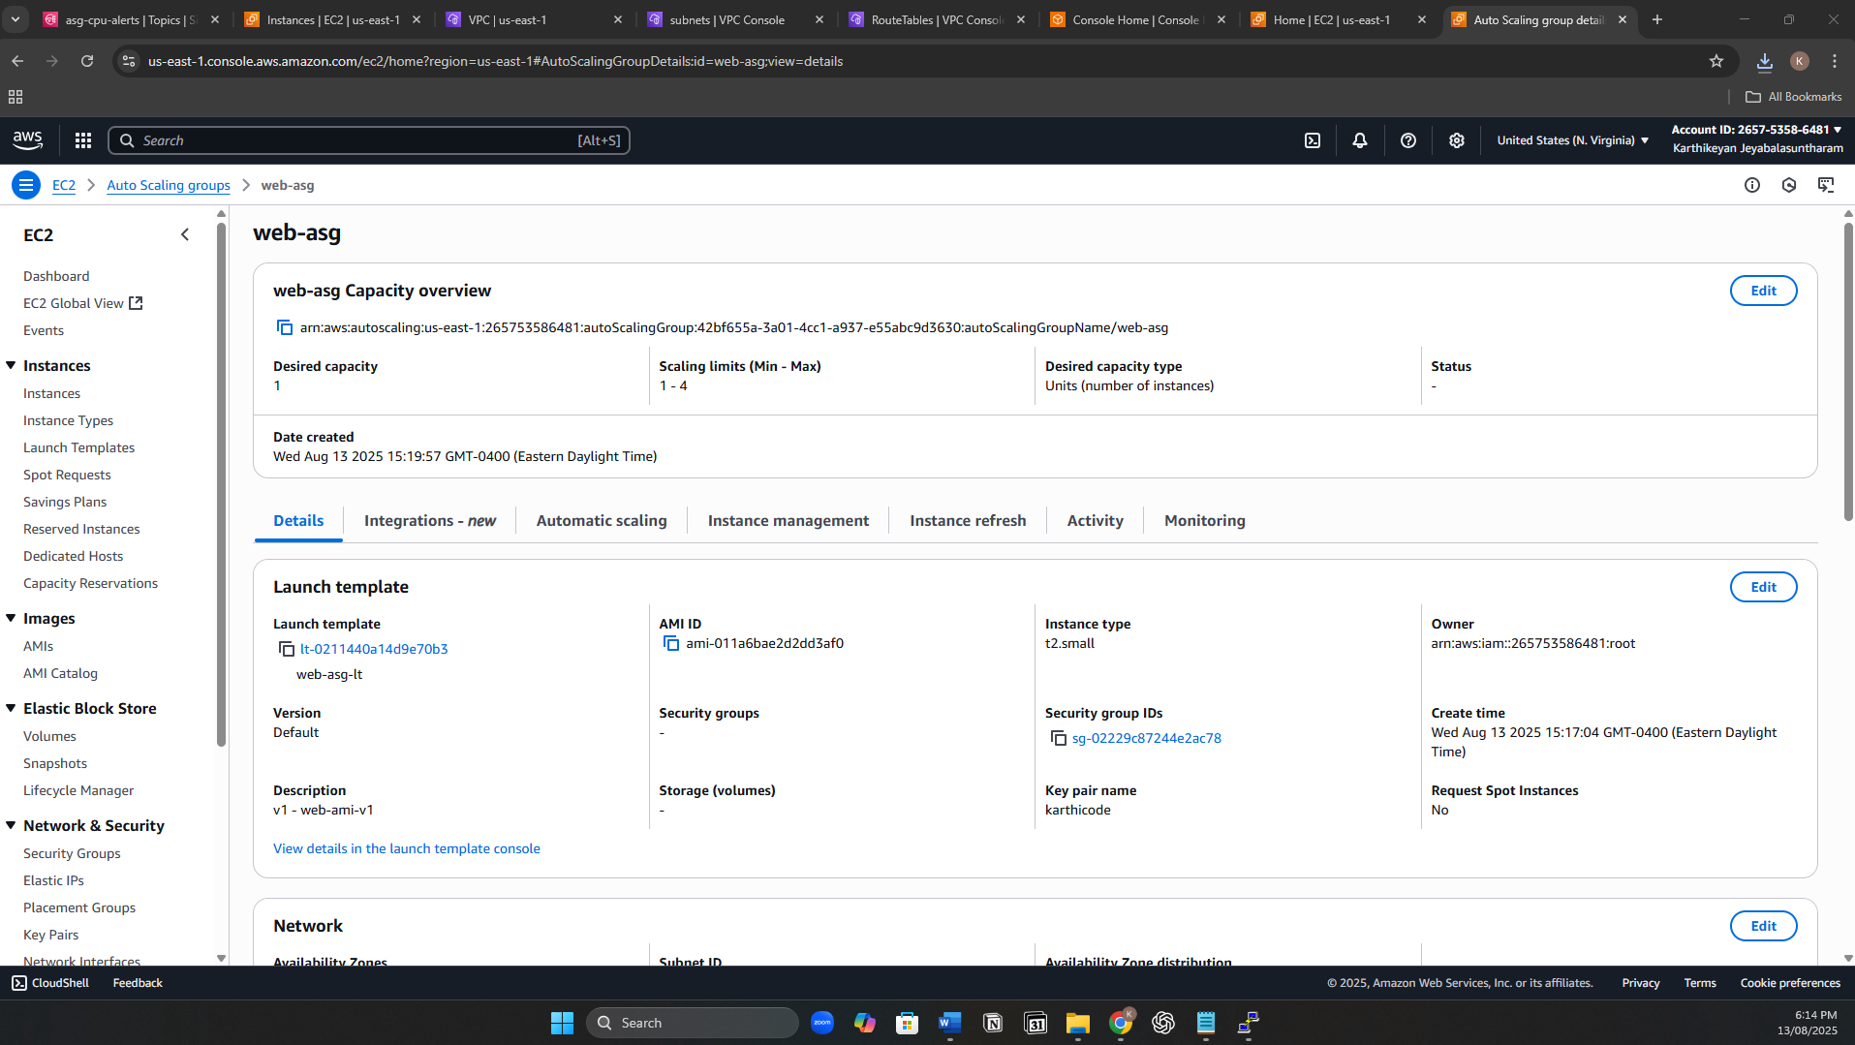

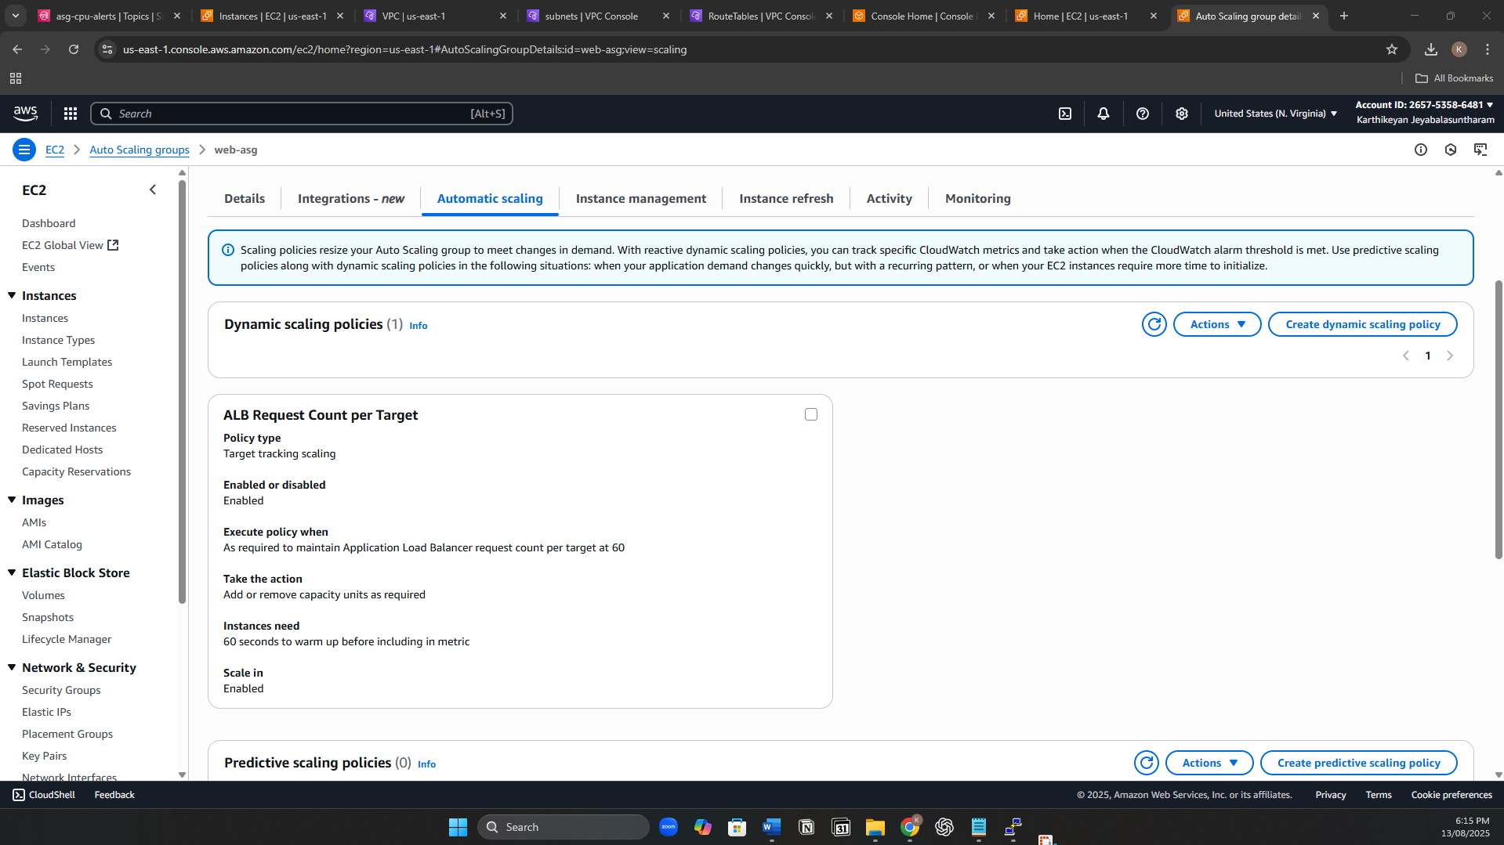

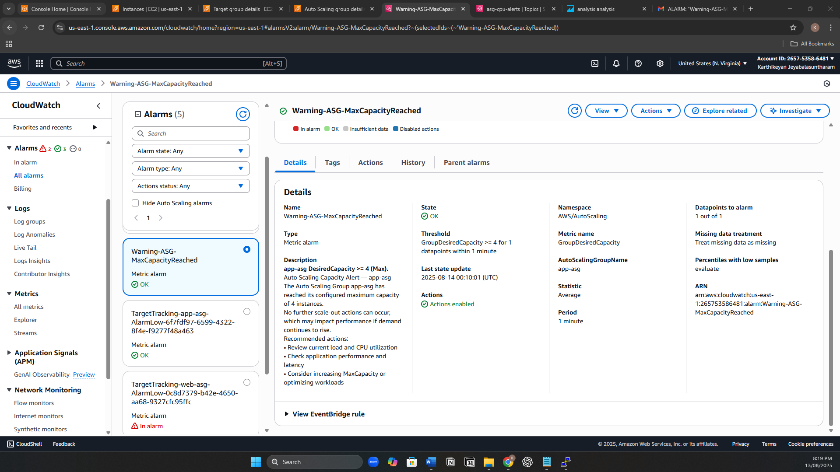

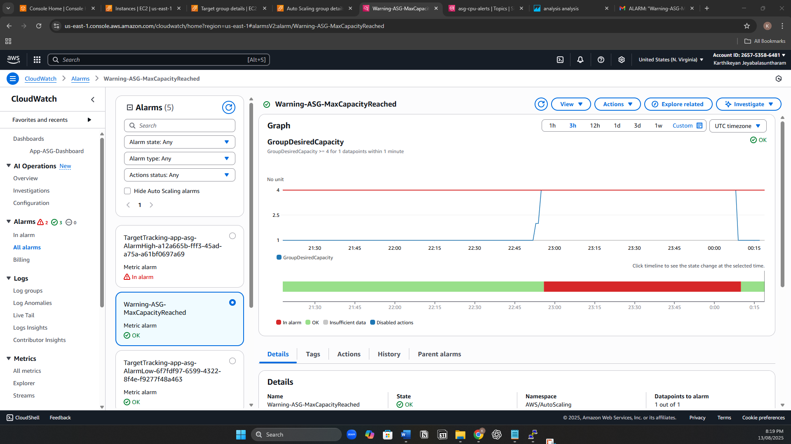

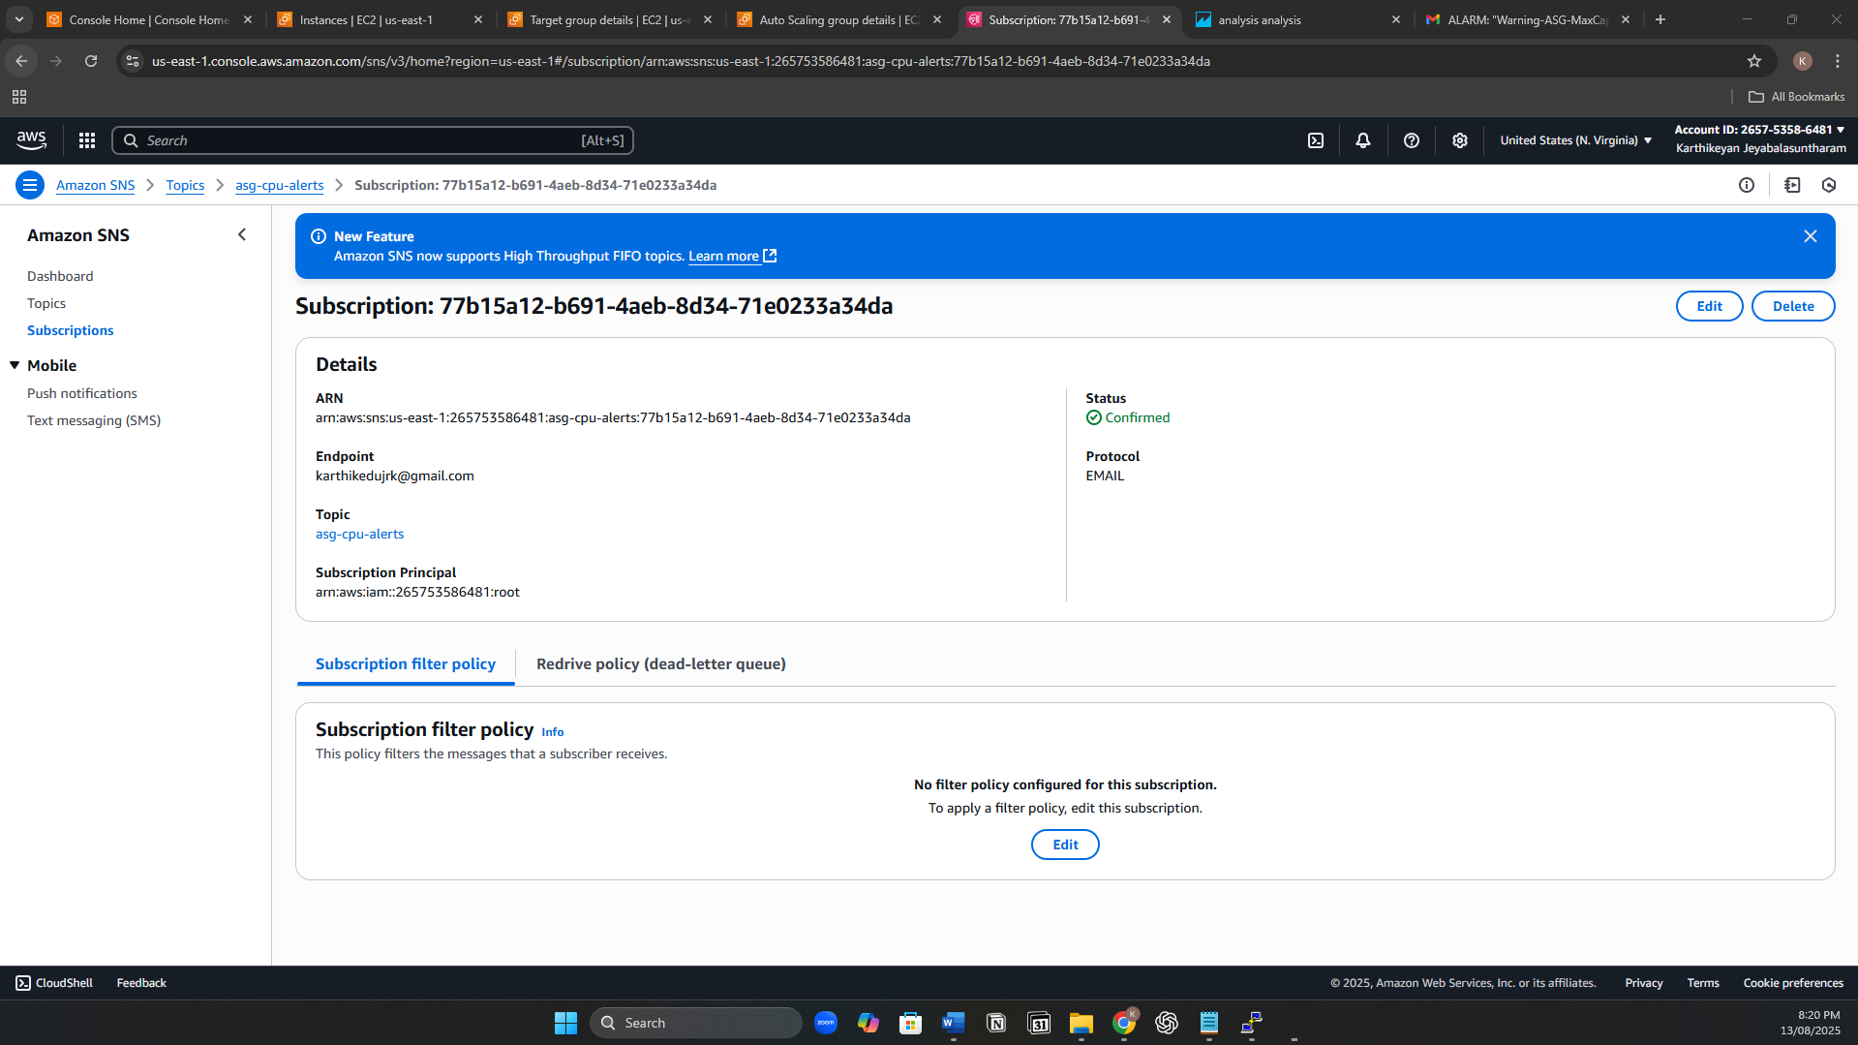

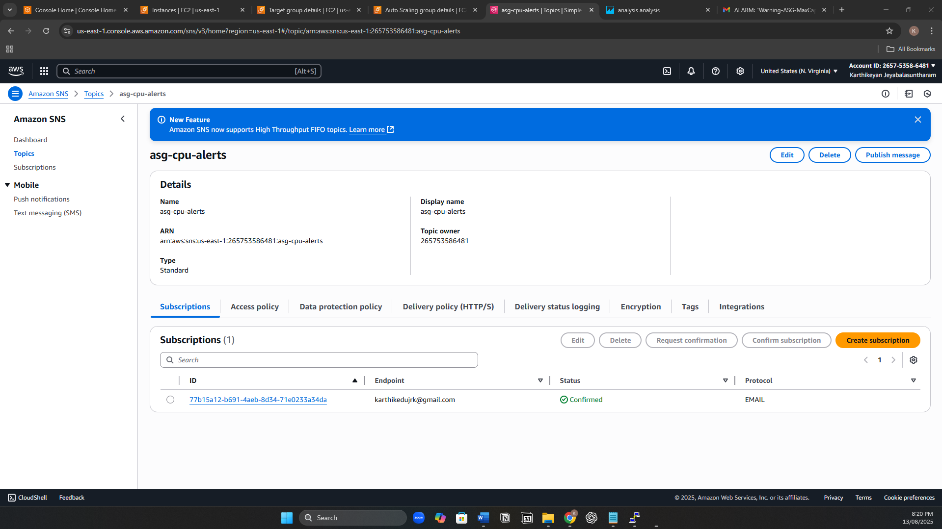

Database Setup

* Launch Amazon RDS MySQL in private DB subnets.
* Assign DB-SG to RDS instance.
* Set database credentials and note the endpoint.
* Update application configuration to connect to RDS endpoint with secure credentials.

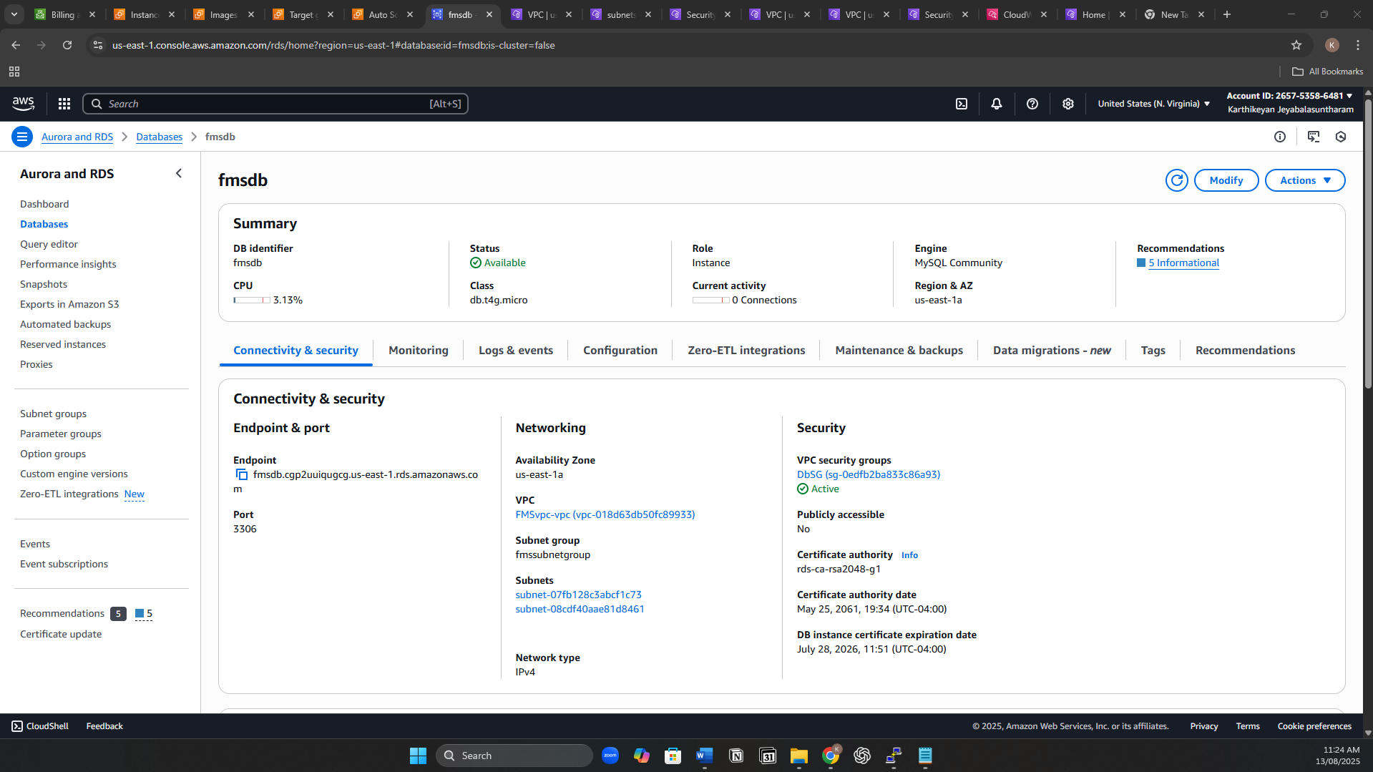

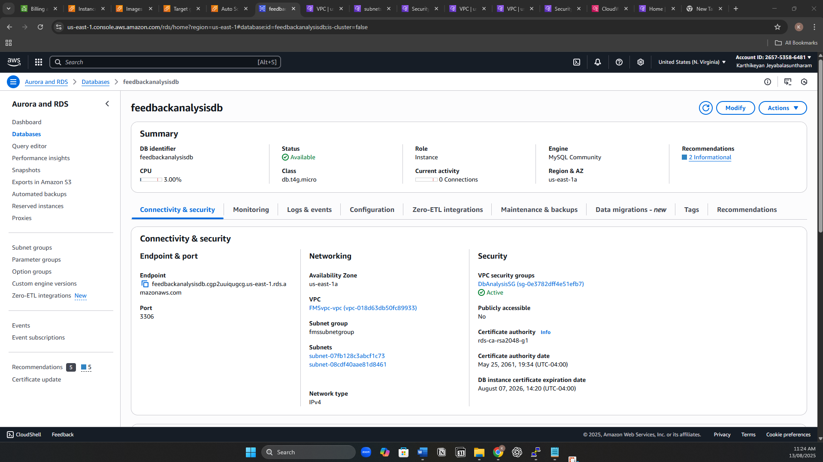

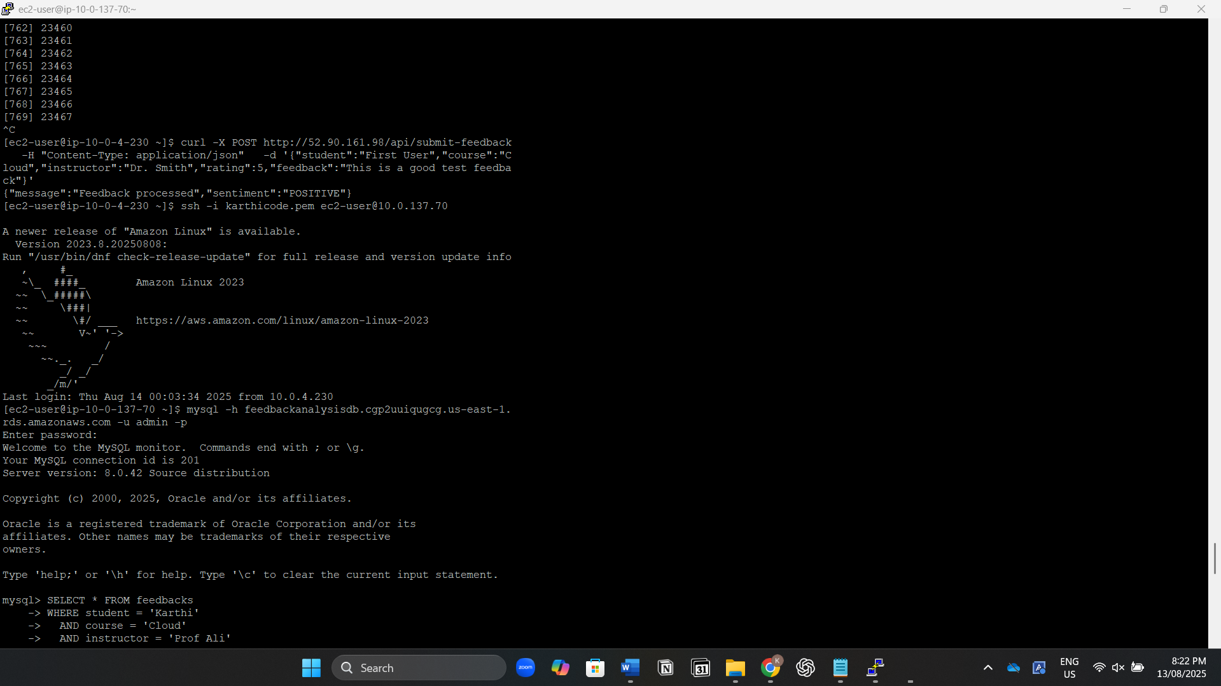

AWS Comprehend Integration

* Create an IAM Role for EC2 with permission comprehend:FullAccess.
* Attach the IAM role to App Tier EC2 instances.
* Update application backend code to:
  + Call AWS Comprehend’s API with user feedback text.
  + Store sentiment result (Positive, Negative, Neutral) along with feedback in RDS.

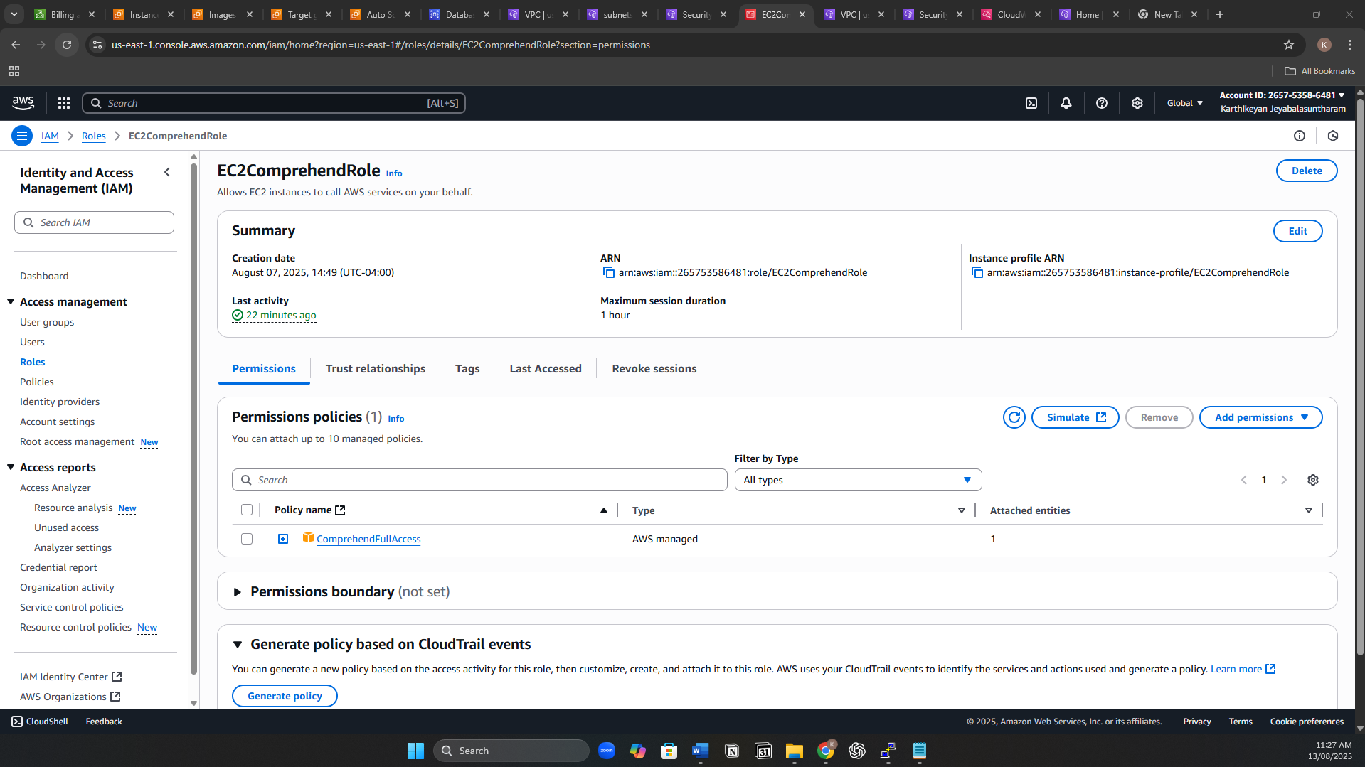

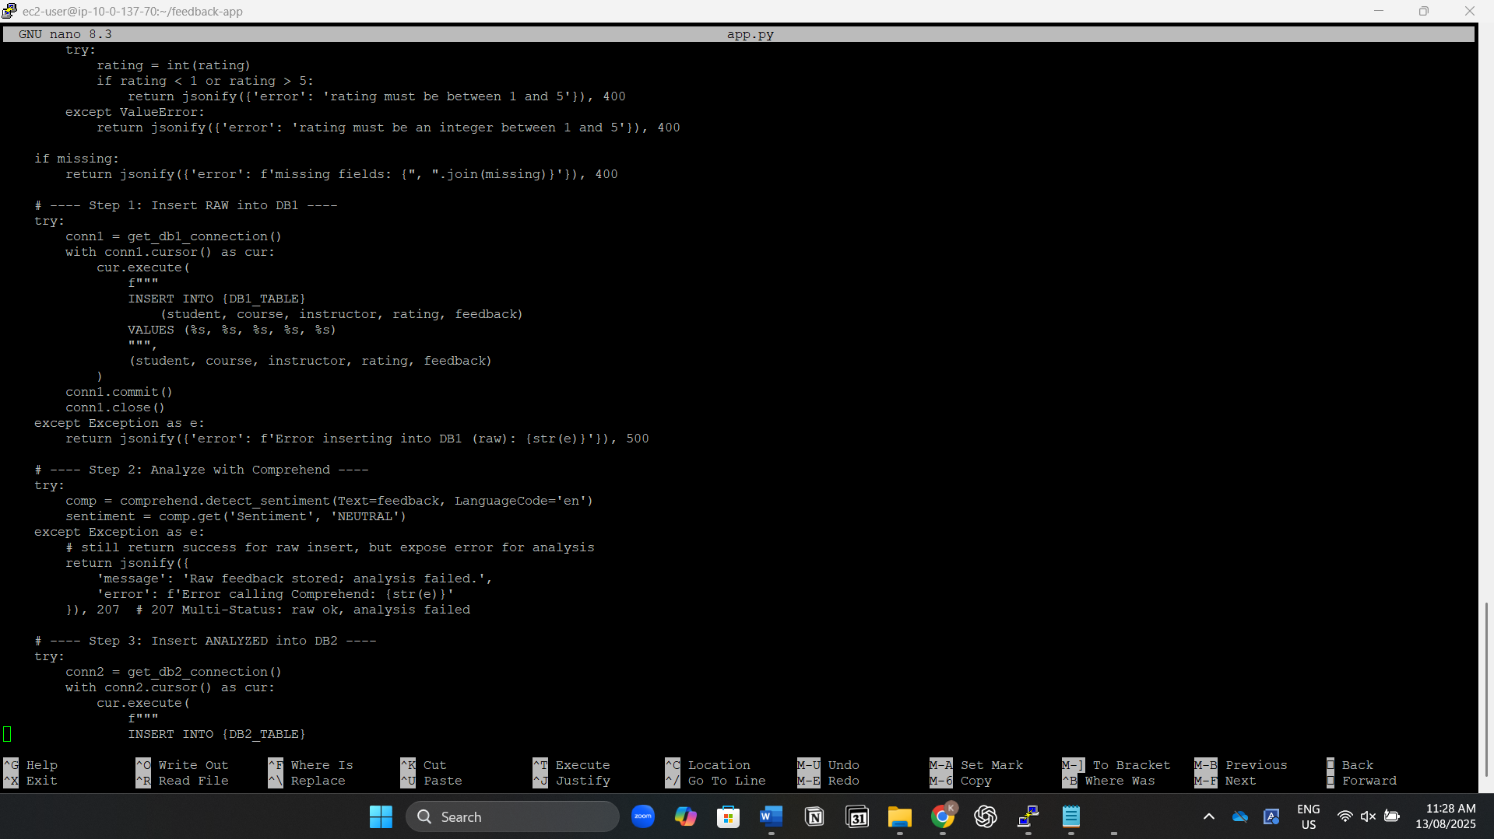

Visualization with QuickSight

* Ensure QuickSight has a VPC connection to access RDS in private subnets.
* In QuickSight, create a new data source and connect to the RDS MySQL instance.
* Create datasets from feedback and sentiment tables.
* Build visual dashboards showing sentiment distribution, rating averages, and trends over time.

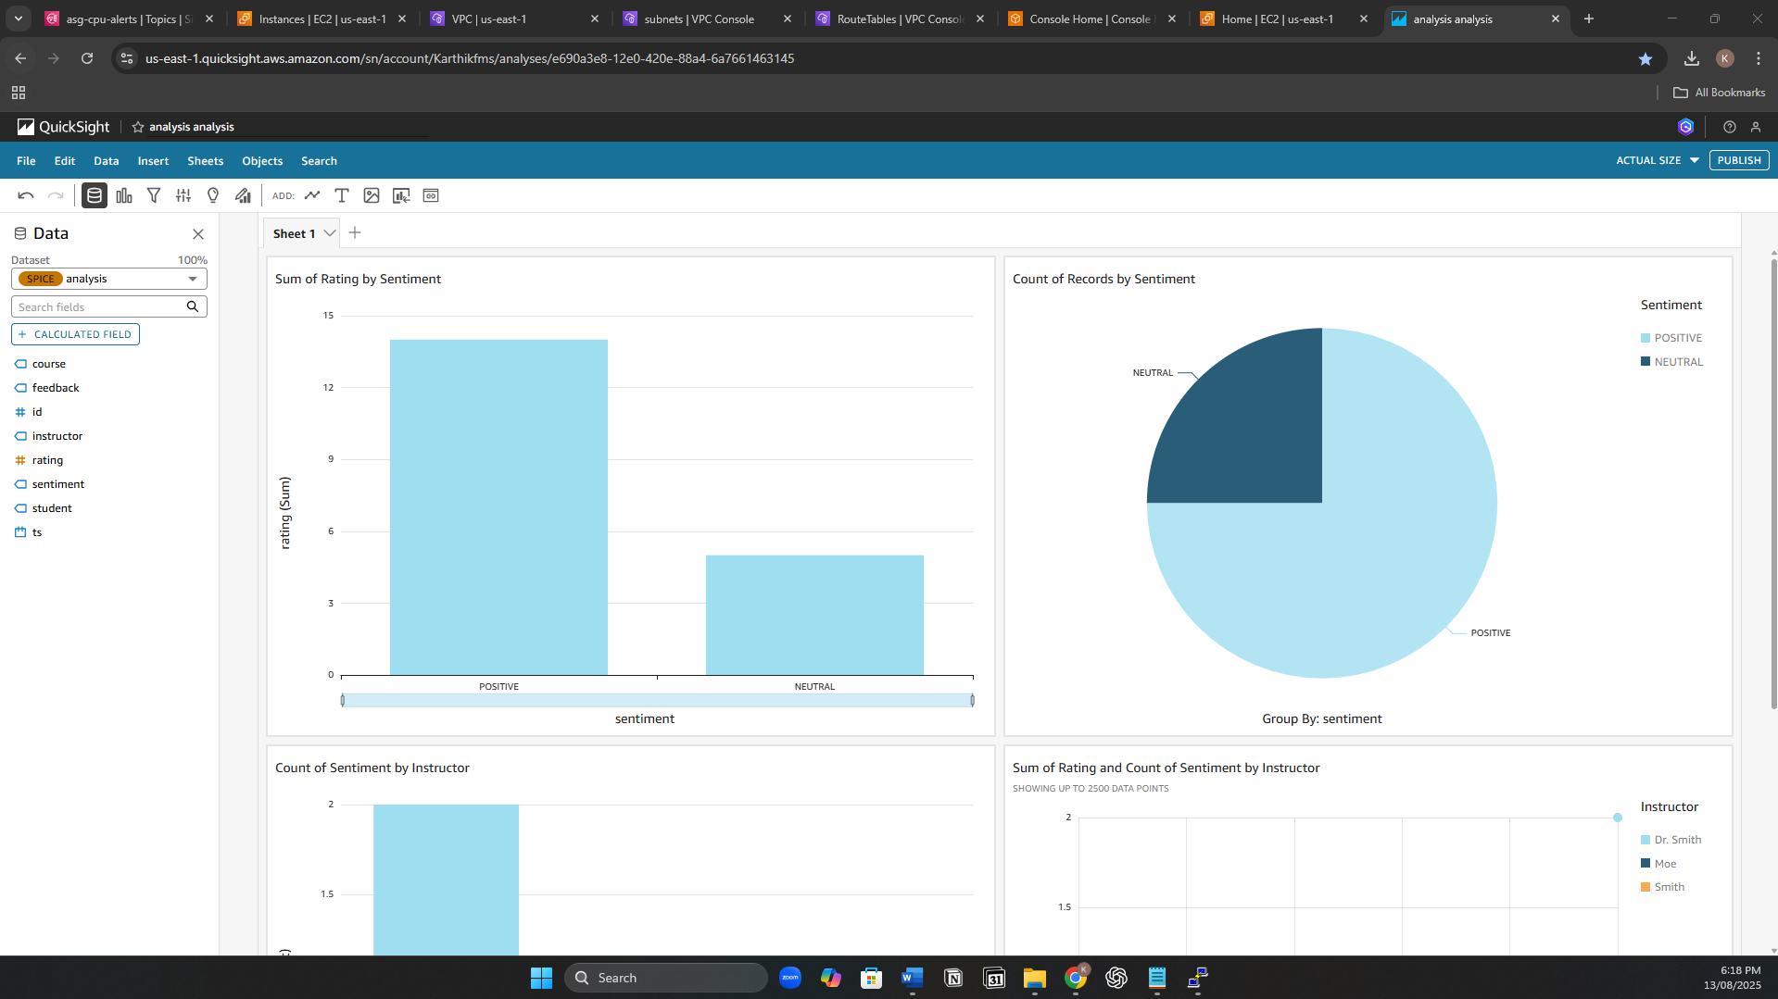

Monitoring & Logging

* Create CloudWatch Alarms for:
  + High CPU utilization on web/app instances.
* Configure alarm actions to send notifications to SNS topic and send email notification.
* Review metrics and alarms regularly to ensure system health and performance.

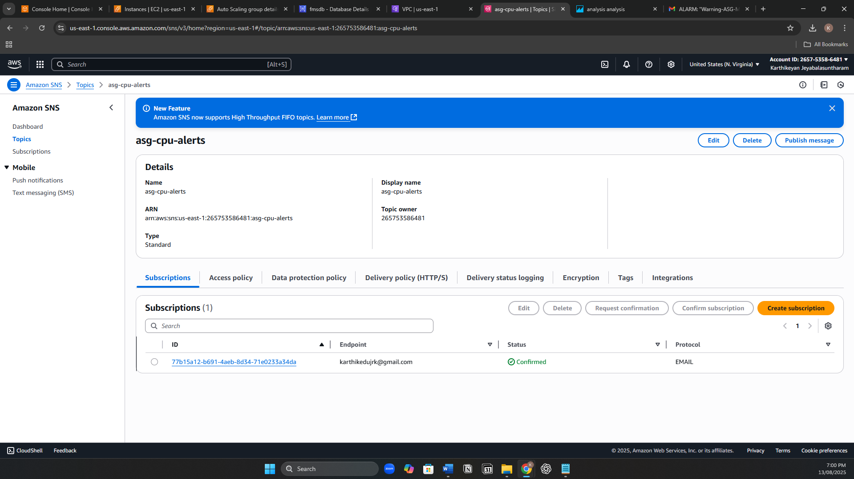

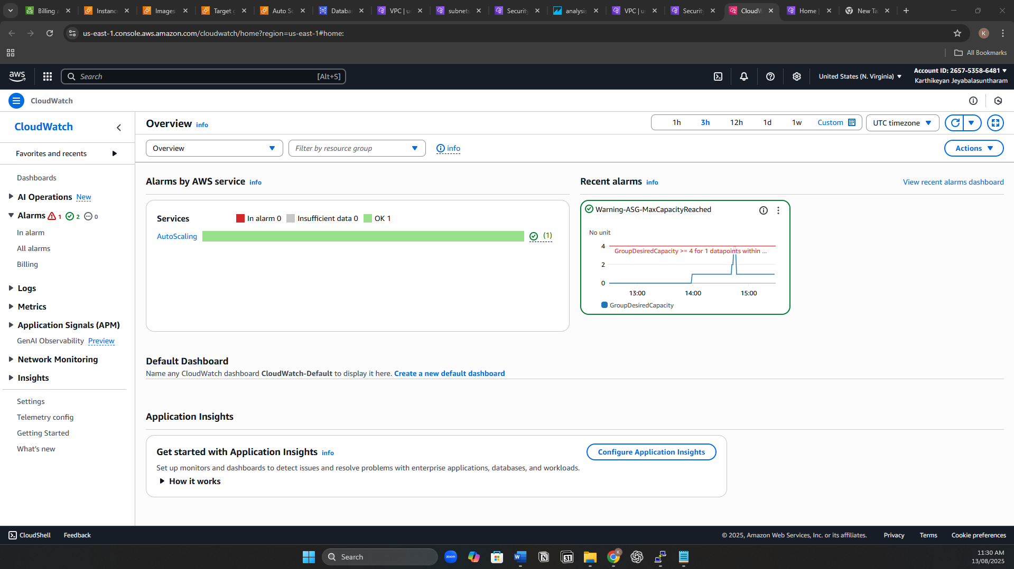

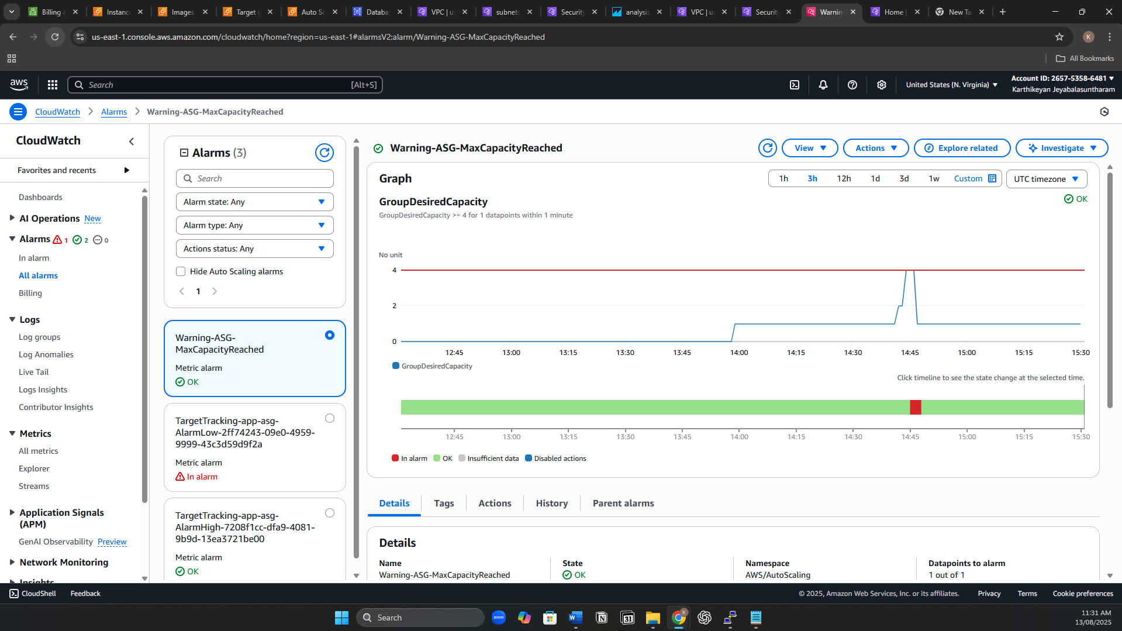

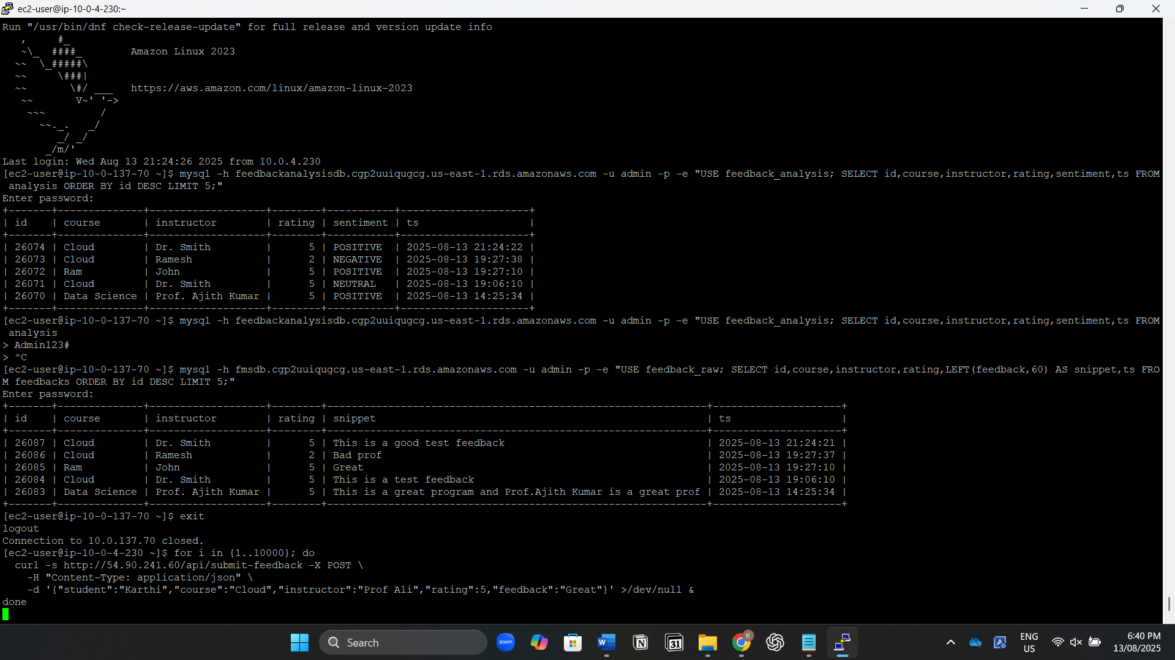

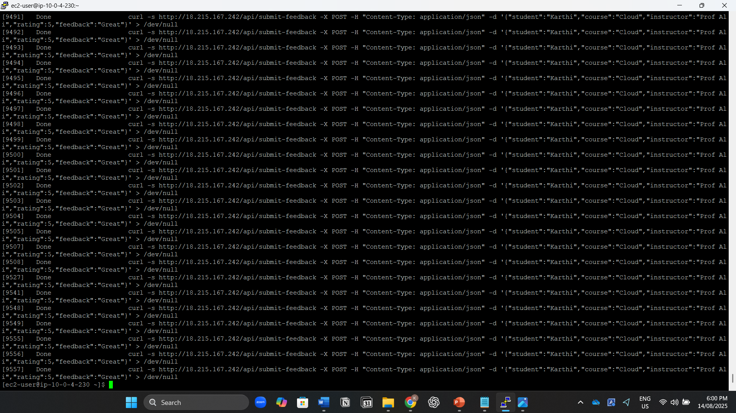

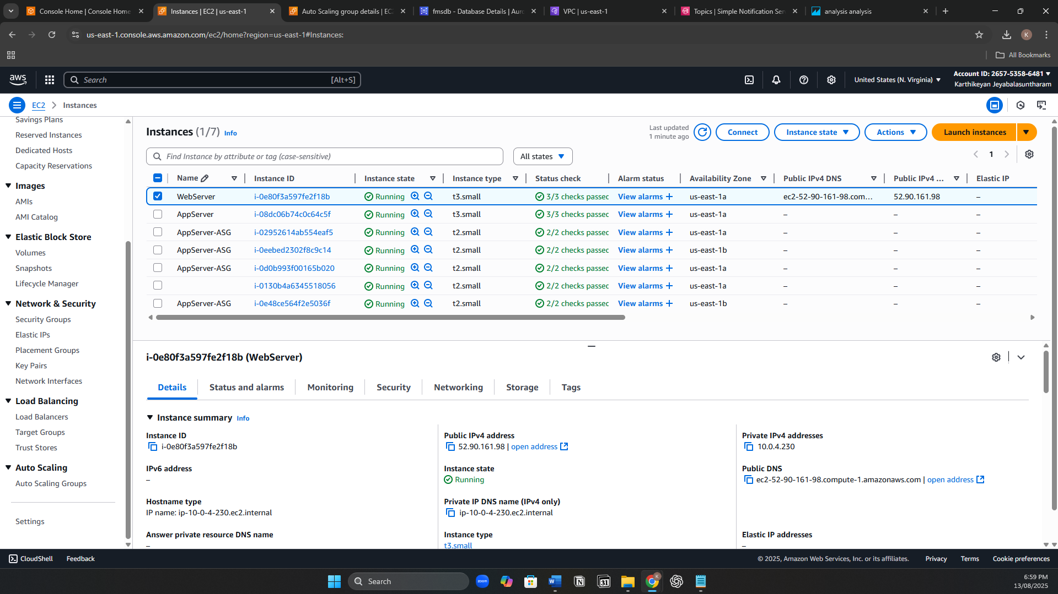

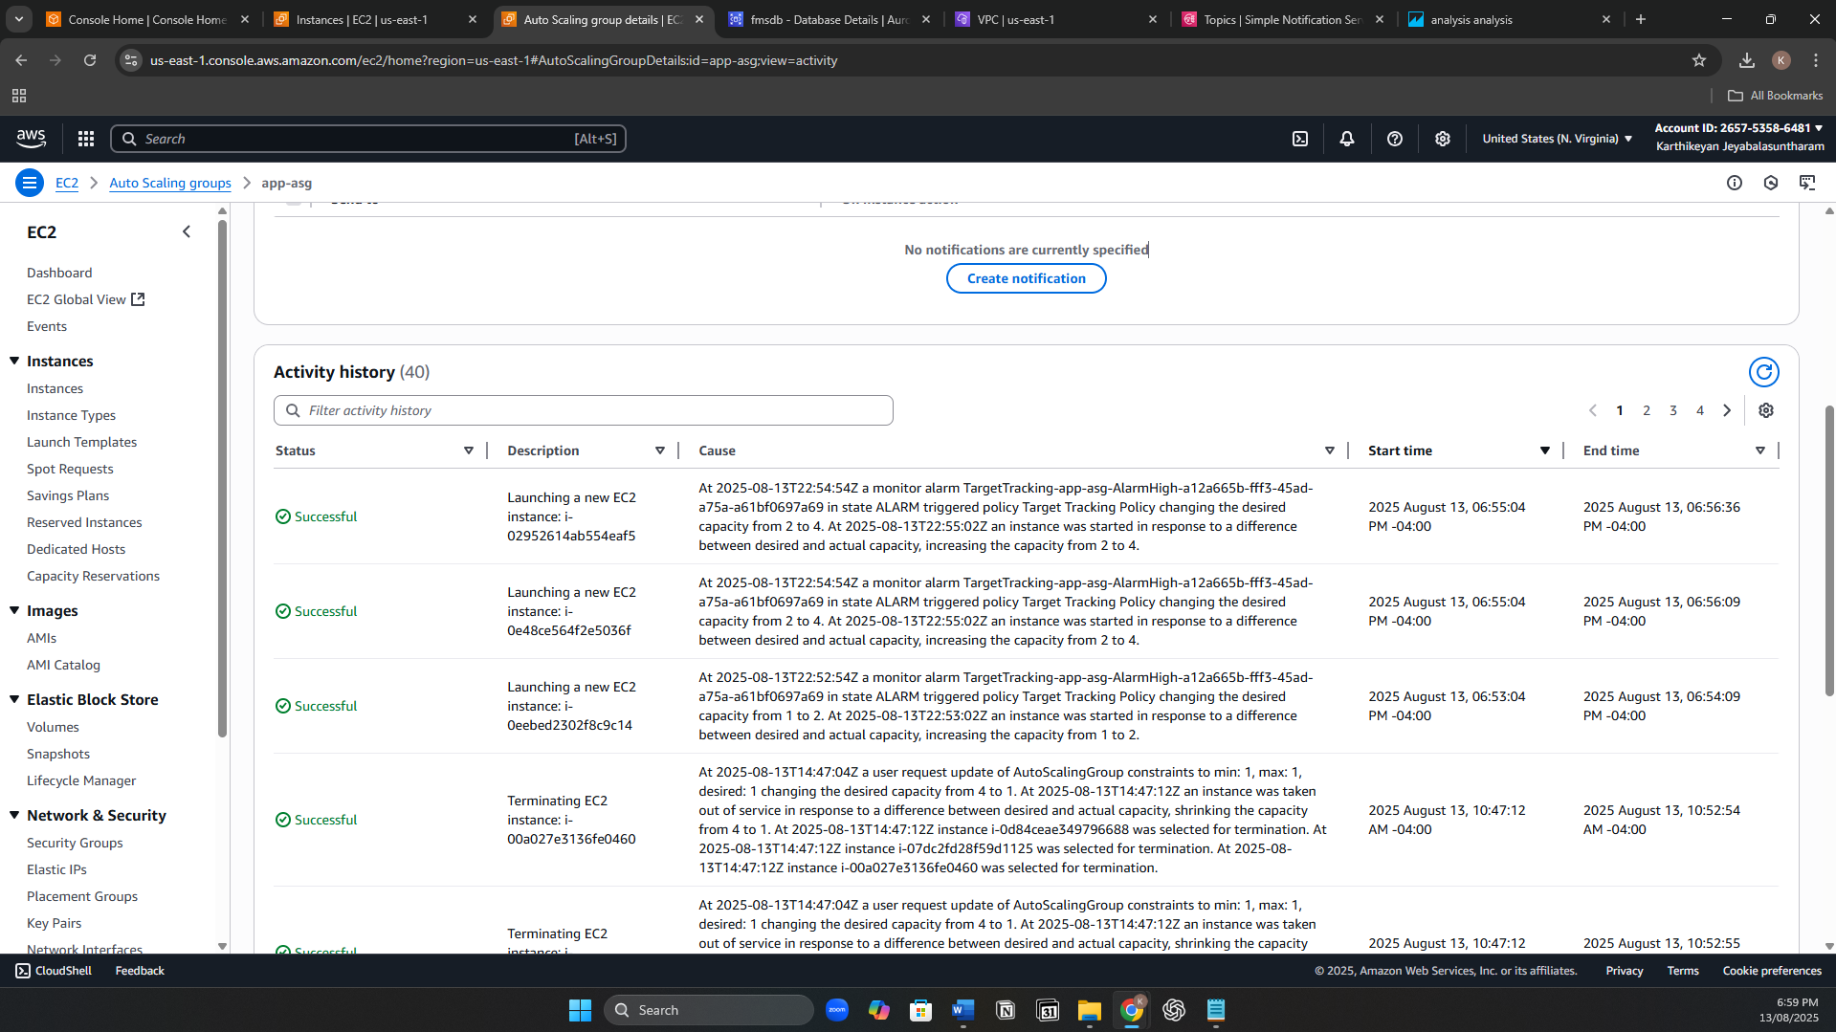

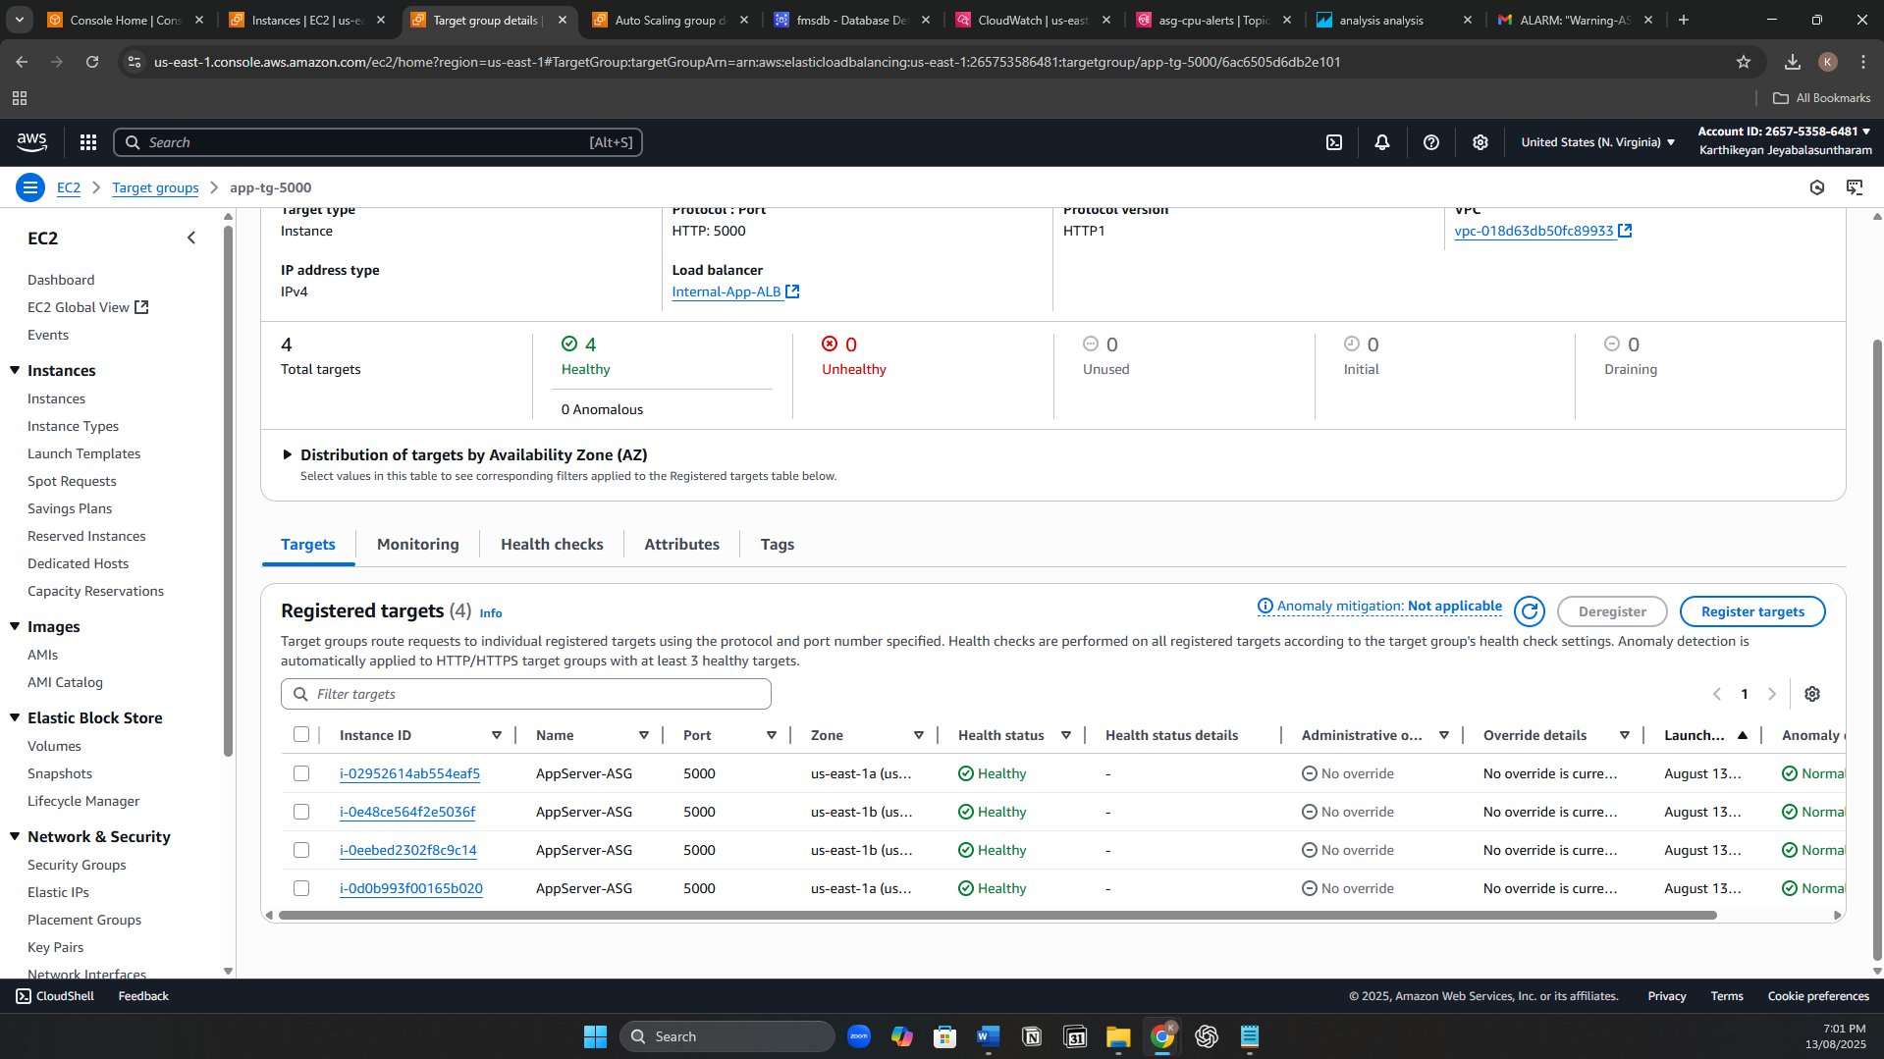

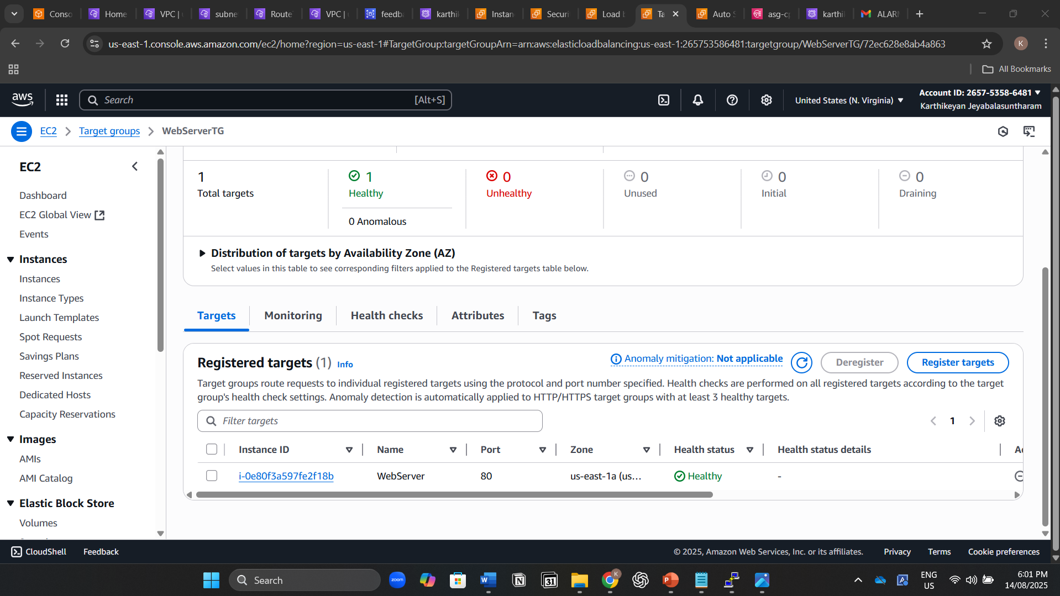

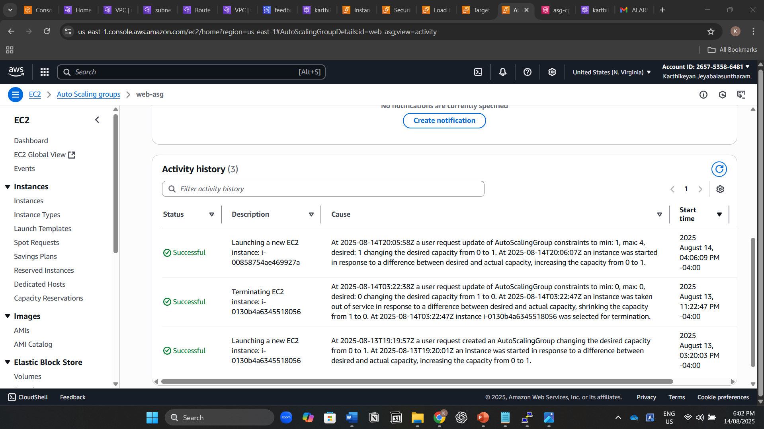

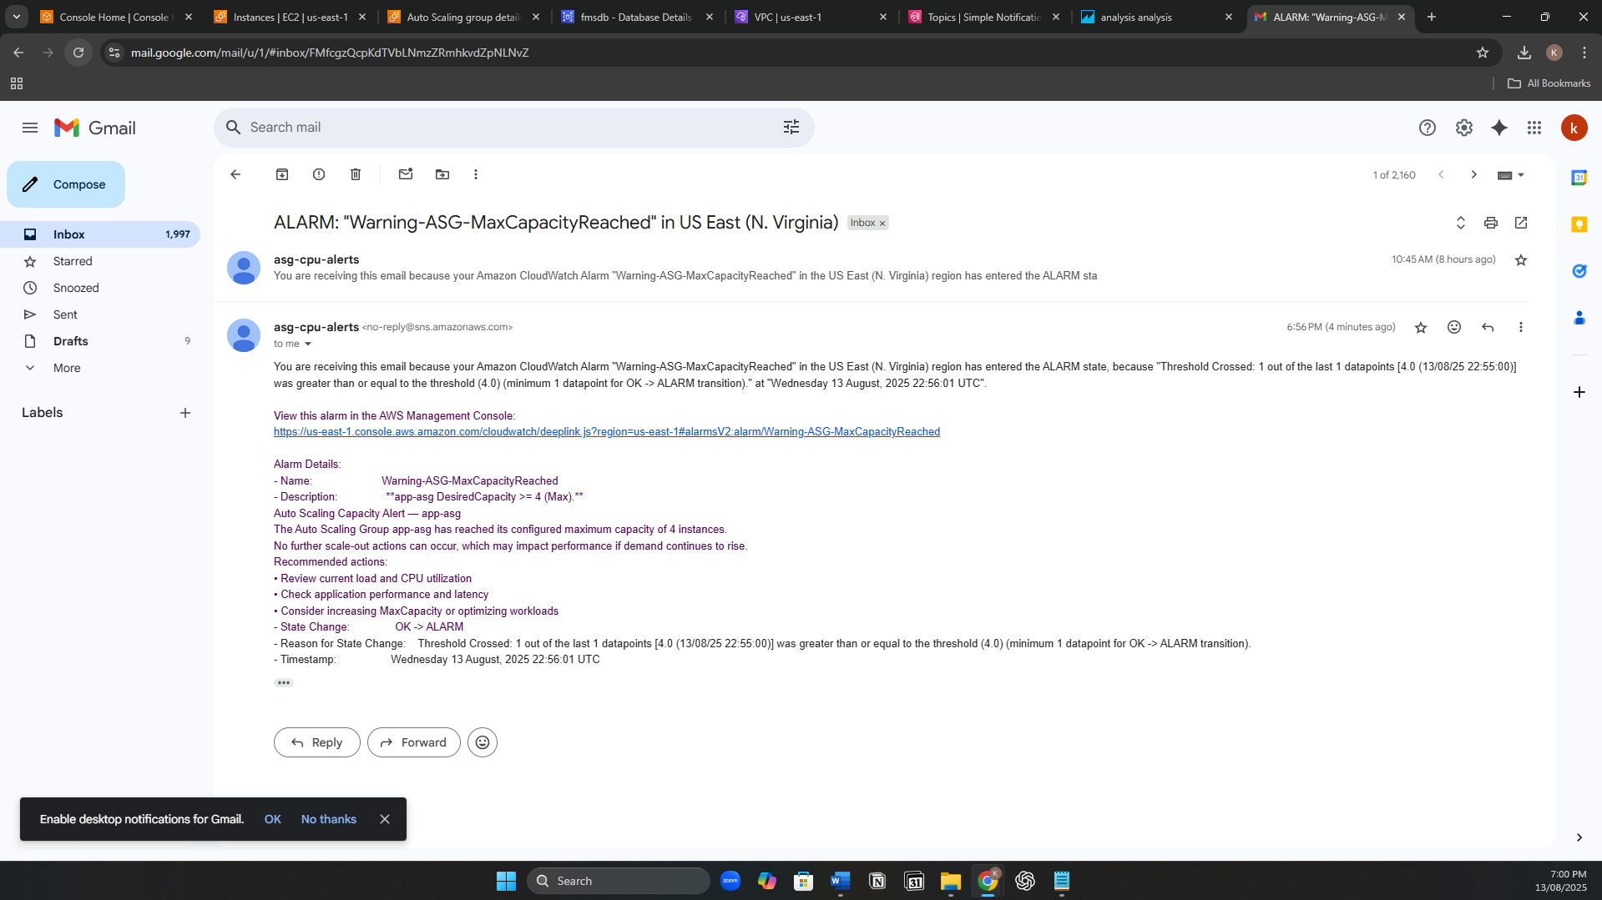

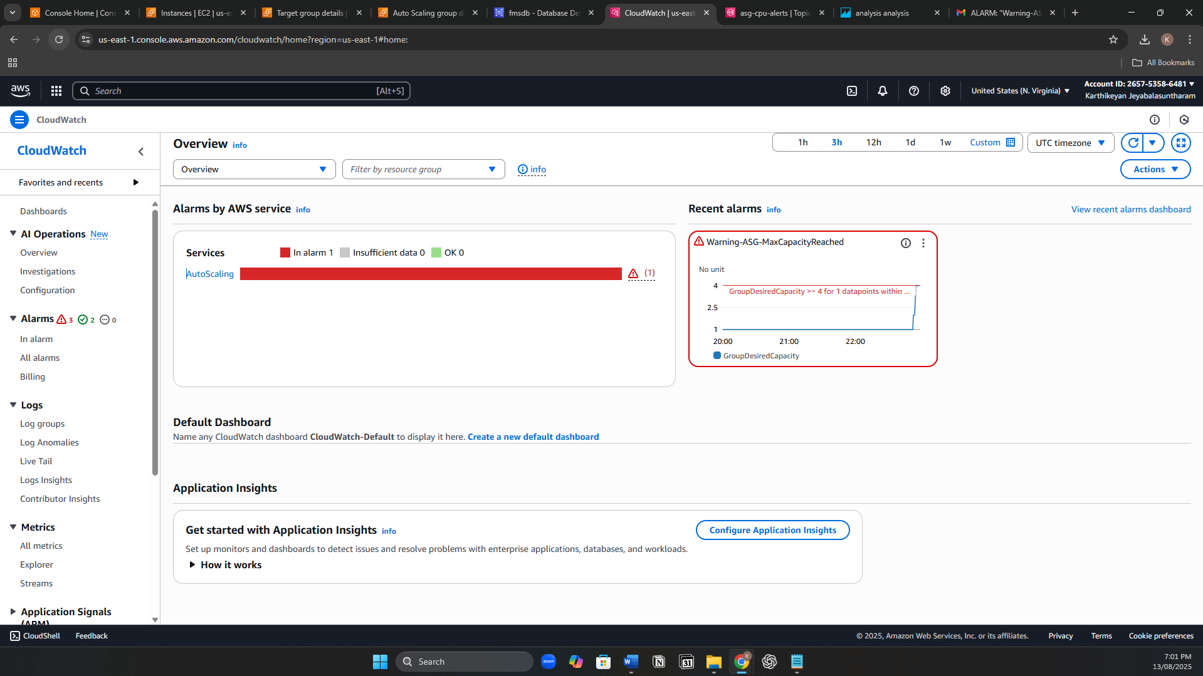

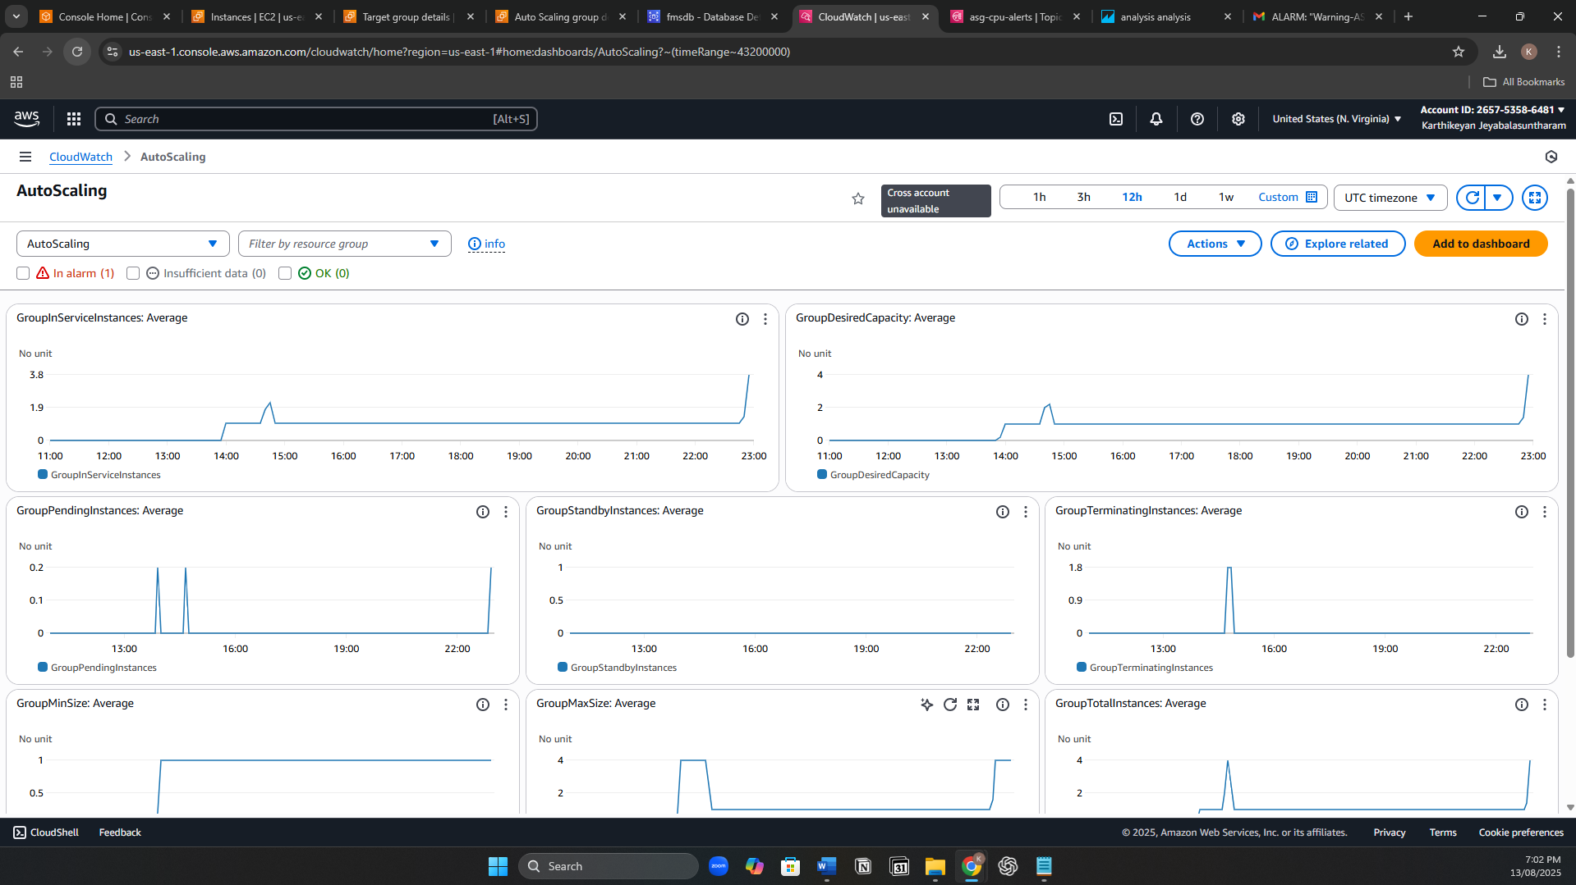

Web Page

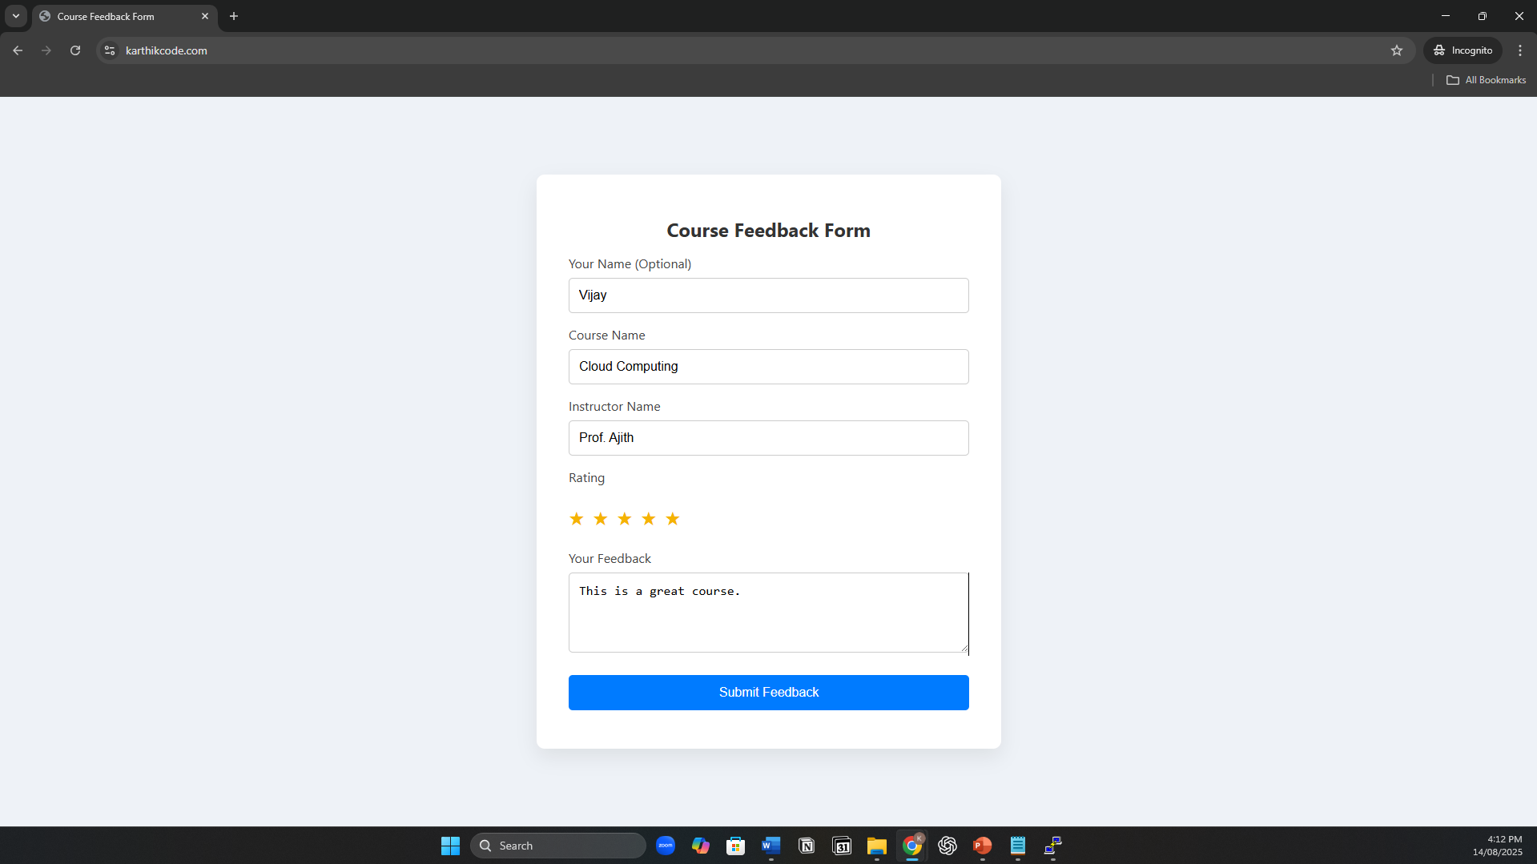

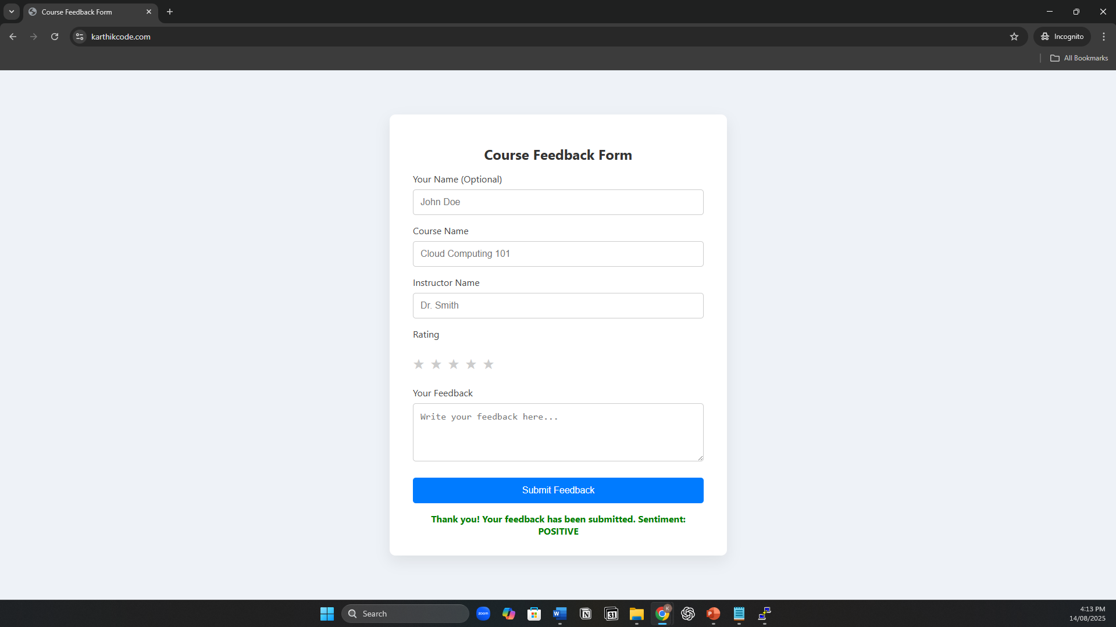

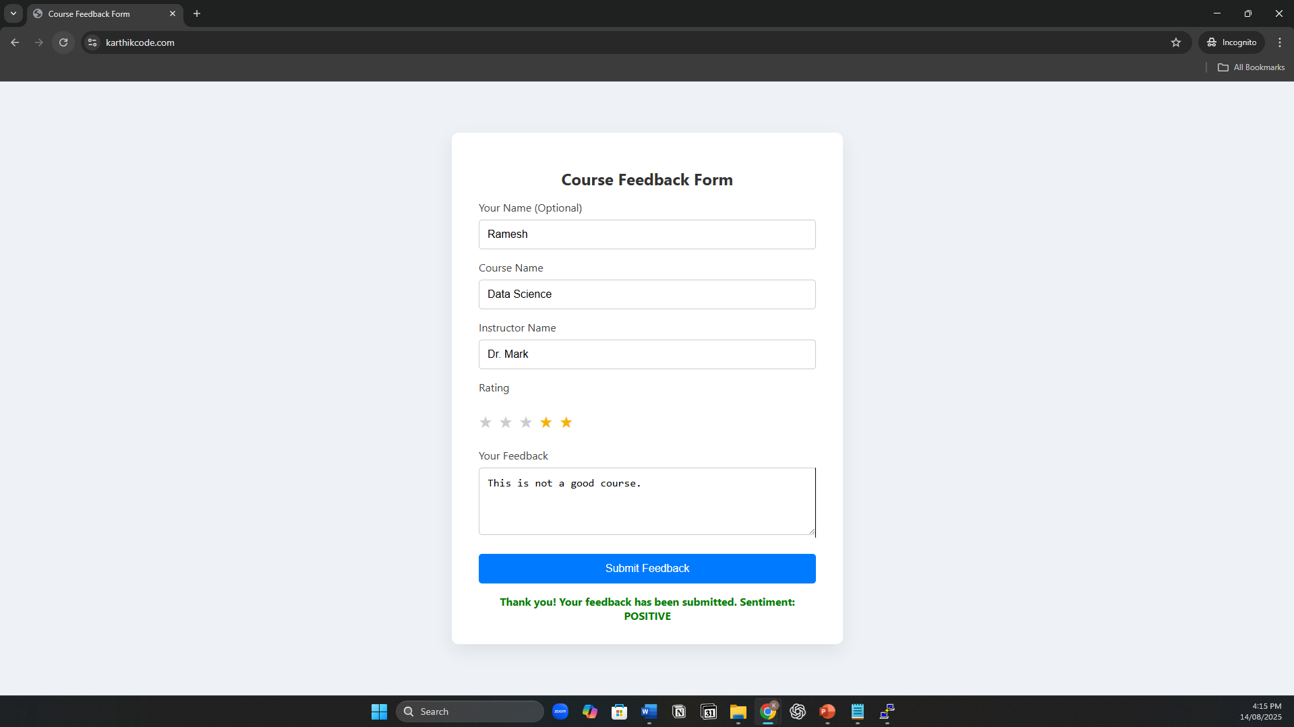

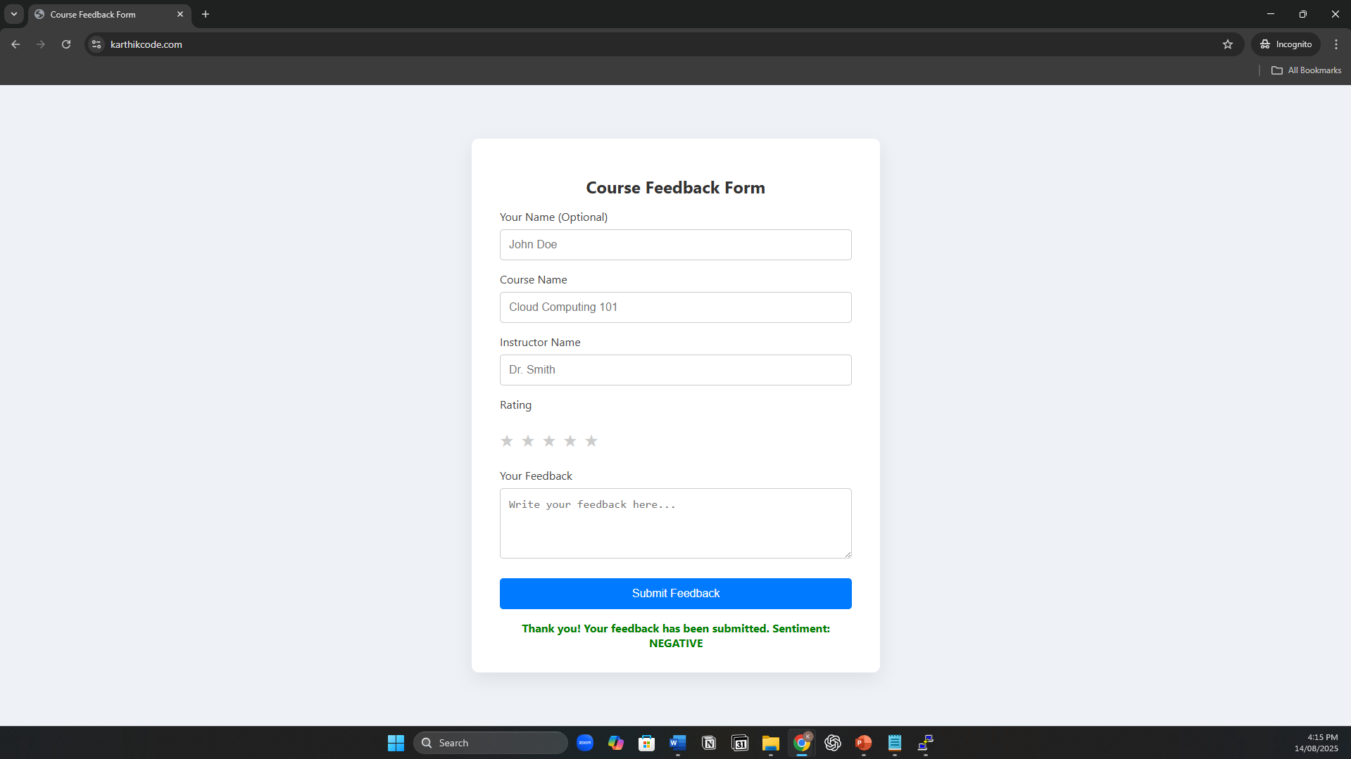

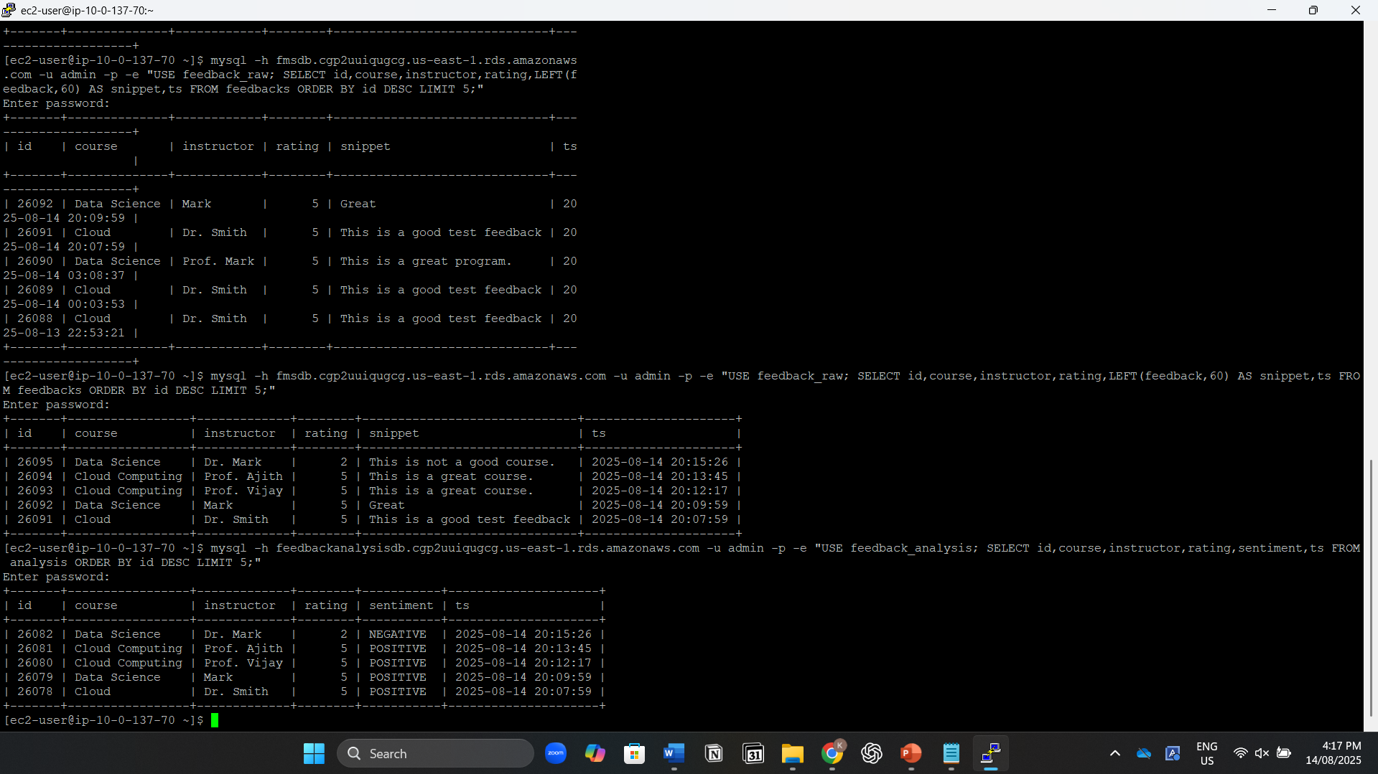

# Conclusion

The AWS Feedback Management System demonstrates how a modern, cloud-native application can combine scalability, security, and intelligence to deliver real business value. By leveraging a three-tier architecture with Auto Scaling Groups, the system adapts seamlessly to changes in traffic, always ensuring consistent performance while optimizing costs.

Integration with AWS Comprehend enables real-time sentiment analysis, transforming raw user feedback into actionable insights. Amazon QuickSight provides interactive dashboards that make it easy to monitor trends and identify areas for improvement. The use of Amazon SNS for Auto Scaling notifications ensures that operational teams are immediately informed of scaling events, while Amazon CloudWatch maintains continuous visibility into the system’s health.